Vintage Model Notes

Contents

1 CECL 3

1.1 What is CECL? 3

1.2 Comments: 3

2 Data 3

2.1 Description 4

3 Model 4

3.1 Dependent Variable 5

3.2 Independent Variables 5

4 Monthly time interval 5

4.1 Fit to training set 8

4.2 Fit to test set 12

4.3 Comments 12

5 Two stage modeling 12

5.1 Stage 1: Logistic regression 13

5.2 Test error 14

5.3 Stage 2: Logistic regression 14

5.4 Fit to training set 16

5.5 Fit to test set 20

6 Specifying economically meaningful variables 20

6.1 Continuous 21

6.2 Categorical 22

6.3 Variables 24

6.4 Ideas for other potential variables not included 24

6.5 Results 25

6.6 Fit to test data 26

7 Gradient boosted model for Stage 1 26

7.1 Fit to test data 29

8 GBM-GAM: 2 part model 29

8.1 Variable selection for Stage 2 GAM 30

9 3 Stage Vintage model 36

9.1 Model specs 36

9.2 Vintage level results 37

9.3 Grouped results 45

9.4 Model Diagnosis (GBC-OLS-OLS) 51

9.5 Model Diagnosis (GBC-RFR-RFR) 53

10 Next steps 58

The final model output is lifetime expected credit losses for loss reserving under current expected credit loss (CECL). This paper will include …

# CECL

## What is CECL?

“The Financial Accounting Standards Board (FASB) voted 5–2 on April 27th to move forward with the proposed Accounting Standards Update, Subtopic 326-20, more commonly known as the current expected credit loss (CECL) model. The final standard, expected to be passed in June 2016, will require institutions to reserve against losses on loans when they originate or acquire them and to re-estimate losses on an ongoing basis. The move to a CECL model is a departure from current GAAP, which requires institutions to defer the recognition of a credit loss until the loss is “probable and estimable,” or has been incurred. The change is in direct response to the most recent global financial crisis.

In the draft standard and subsequent Transition Resource Group (TRG) meetings, FASB members were intentionally non-prescriptive regarding acceptable methodologies available to institutions performing their quantitative loss calculations under the CECL standard. Board member Lawrence W. Smith reiterated the non-prescriptive nature, saying, “We are not prescribing specific methods of doing the allowance at all.” Instead, the FASB listed examples of CECL-compliant calculations in their draft, including vintage analysis and the historical loss rate approach. Institutions will be free to use their judgment when developing estimation techniques as long as they are consistently applied over time and aim to faithfully estimate an actual life of loan loss.”

Source: <https://www.sageworks.com/banking/resources/CECL-Historical-Loss-Misconceptions/>

## Comments:

1. How institutions adopt CECL depends on what types of data they collect currently and plan to in the future
2. The policy is non-prescriptive -> more flexibility in what models can be used
3. Allowed models: vintage analysis, historical loss rate approach
4. Given model is compliant with CECL, each institution has different modeling requirements and standards

# Data

This paper will use Fannie Mae’s Single-Family Loan Performance credit dataset to test model hypotheses. Economic data will be obtained from FRED.

“Fannie Mae provides loan performance data on a portion of its single-family mortgage loans to promote better understanding of the credit performance of Fannie Mae mortgage loans…

The Single Family Fixed Rate Mortgage (primary) dataset contains a subset of Fannie Mae’s 30-year and less, fully amortizing, full documentation, single-family, conventional fixed-rate mortgages. This dataset does not include data on adjustable-rate mortgage loans, balloon mortgage loans, interest-only mortgage loans, mortgage loans with prepayment penalties, government-insured mortgage loans, Home Affordable Refinance Program (HARP) mortgage loans, Refi Plus™ mortgage loans, or non-standard mortgage loans. Certain types of mortgage loans (e.g., mortgage loans with LTVs greater than 97 percent, Alt-A, other mortgage loans with reduced documentation and/or streamlined processing, and programs or variances that are ineligible today) have been excluded in order to make the dataset more reflective of current underwriting guidelines. Also excluded are mortgage loans originated prior to 1999, mortgage loans subject to long-term standby commitments, sold with lender recourse or subject to certain other third-party risk-sharing arrangements, or that were acquired by Fannie Mae on a negotiated bulk basis.

The initial population of mortgage loans in the primary dataset included Fannie Mae acquisitions between January 1, 2000 and March 31, 2012 with corresponding monthly performance data as of December 31, 2012. Every quarter following the initial release, Fannie Mae updates the acquisition data to include a new quarter of acquired mortgage loans as of the prior year in addition to providing updated performance data as of the previous quarter. Fannie Mae releases updated information on or after the 20th of the month following the end of the quarter.”

Source: <http://www.fanniemae.com/portal/funding-the-market/data/loan-performance-data.html>

## Description

Fannie Mae’s loan data come in 2 files:

1. “Acquisition” file: static mortgage loan data at the time of the mortgage loan’s origination and delivery to Fannie Mae (1 row per loan)
   1. Loan identifier
   2. Origination date
   3. Original interest rate
   4. Original Loan-to-Value ratio
   5. Credit score
   6. Origination channel
   7. And more…
2. “Performance” file: monthly performance data for each loan, from acquisition up until its current status as of the previous quarter (1 row per month of loan activity per loan)
   1. Loan identifier
   2. Calendar date
   3. Loan age
   4. Current unpaid principal balance (UPB)
   5. And more…

# Model

Our analysis will aggregate loans by vintage. We are free to choose the time interval of the vintage and will use monthly periods. Loans that originated in the same month of the same year are grouped together as one vintage.

Final output of the model is the percentage of a vintage’s original balance expected to be lost (ie. % of original balance that defaults plus any proceeds from resale/modification). To illustrate the methodology, below we discuss a simplified example. The columns are:

* ORIG_DTE: Year and month in which loans were originated (ie. vintage)
* ORIG_AMT: Original amount loaned for each vintage
* Net loss ratio: % of ORIG_AMT that was lost in each subsequent month (Month 0 is the month the loans were originated). Negative value if there was a gain due to default.

|  |  |  |  |  |  |  |
| --- | --- | --- | --- | --- | --- | --- |
| **ORIG_DTE** | **ORIG_AMT** |  | **Net loss ratio** | |  |  |
|  | **Loan age ->** | **Month 0** | **Month 1** | **Month 2** | **Month 3** | **Month 4** |
| 2018Q2 | 500000 |  |  |  |  |  |
| 2018Q1 | 1000000 | 0.10% |  |  |  |  |
| 2017Q4 | 800000 | 0.00% | 0.23% |  |  |  |
| 2017Q3 | 700000 | 0.05% | 0.00% | 1.00% |  |  |
| 2017Q2 | 1100000 | 0.00% | 0.00% | 0.04% | 0.00% |  |
| 2017Q1 | 900000 | 0.20% | 0.35% | 0.40% | 0.15% | 0.04% |

Data in the gray cells indicate the current period and we do not yet know how much was lost. Our goal is to project losses for loans originated in 2018/2. We make the assumption that we can estimate month ‘X’s’ net loss ratio by taking some average of month ‘X’s’ net loss ratios of previous loans. For instance, we estimate the net loss ratio of 2018/2 loans in Month 1 by using the net loss ratio of 2017/12 and 2017/11 loans in Month 1 (0.23% and 0% respectively). Of course, as discussed, we have more data than just historical net loss ratios of past loans. Our full model will include these other variables.

## Dependent Variable

The dependent variable is defined as the percentages in the table. It is the net loss divided by the original balance for each vintage:

$${Net loss ratio}_{t}={{Net loss of defaulted loans}_{t}}/{{Total ORIG_AMT of vintage}_{0}}$$

## Independent Variables

The model has 3 groups of independent variables:

1. Age
   * Average loan default rates grow from a low level to a peak, say, six months after origination, before tapering off as only the best risks remain on the books
2. Loan quality
   * These include the origination characteristics of the loan, such as initial rate, loan-to-value ratio and credit score. With vintage analysis, we take a weighted average of these variables.
3. Selection of economic and risk drivers
   * The economic environment has a significant impact on default. Variables such as GDP growth rate and inflation will be included.
   * three broad classes of variables:

1. overall level of economic activity (e.g., the unemployment rate, the rate of inflation, and the NBER recession indicator)

2. the direction in which the economy is moving (e.g., the growth rates of GDP and industrial production)

3. conditions in the financial markets (e.g., interest rates and stock market returns)

(Figlewski)

# Monthly time interval

Given greater computational capacity, we reduce the time interval from quarterly to monthly, enabling us to conduct a finer level of analysis.

Data: Quarter 4 data from years 2000 to 2005, inclusive.

A much wider range of data are now available. We use the vintage months between 2000 and 2005 August for training and 2005 September to December as the test set. We fit a tobit model using best forward subset selection based on AIC as above. The model is:

Call:

vglm(formula = "dflt_pct ~ bs(AGE, knots=quantile(AGE, probs=seq(0, 1, 0.2))[2:5]) + PROP_TYP_CO_wm+PROP_TYP_CP_wm+PROP_TYP_MH_wm+PROP_TYP_PU_wm+

bs(AGE, knots=quantile(AGE, probs=seq(0, 1, 0.2))[2:5])*(PURPOSE_C_wm+PURPOSE_P_wm)+

bs(AGE, knots=quantile(AGE, probs=seq(0, 1, 0.2))[2:5])*sqrt(I_count)+

bs(AGE, knots=quantile(AGE, probs=seq(0, 1, 0.2))[2:5])*ORIG_RT_wm+

NUM_UNIT_wv*monthly_rGDP",

family = tobit(Lower = 0), data = train, trace = T)

Pearson residuals:

Min 1Q Median 3Q Max

mu -2.152 -0.5238 -0.2167 0.2443 13.08

loge(sd) -5.186 -1.0167 0.0368 0.1900 140.99

Coefficients:

Estimate Std. Error z value

(Intercept):1 -8.692e-04 2.235e-03 -0.389

(Intercept):2 -8.042e+00 1.564e-02 -514.139

bs(AGE, knots = quantile(AGE, probs = seq(0, 1, 0.2))[2:5])1 4.012e-05 3.131e-03 0.013

bs(AGE, knots = quantile(AGE, probs = seq(0, 1, 0.2))[2:5])2 -4.945e-04 2.004e-03 -0.247

bs(AGE, knots = quantile(AGE, probs = seq(0, 1, 0.2))[2:5])3 -3.734e-04 2.479e-03 -0.151

bs(AGE, knots = quantile(AGE, probs = seq(0, 1, 0.2))[2:5])4 2.563e-03 2.219e-03 1.155

bs(AGE, knots = quantile(AGE, probs = seq(0, 1, 0.2))[2:5])5 -1.196e-03 2.597e-03 -0.461

bs(AGE, knots = quantile(AGE, probs = seq(0, 1, 0.2))[2:5])6 4.068e-03 3.134e-03 1.298

bs(AGE, knots = quantile(AGE, probs = seq(0, 1, 0.2))[2:5])7 -1.207e-02 9.862e-03 -1.224

PROP_TYP_CO_wm 2.531e-04 8.393e-04 0.302

PROP_TYP_CP_wm -9.807e-03 1.858e-03 -5.279

PROP_TYP_MH_wm -1.132e-02 5.117e-03 -2.212

PROP_TYP_PU_wm 6.538e-04 3.142e-04 2.081

PURPOSE_C_wm -1.521e-03 2.483e-03 -0.613

PURPOSE_P_wm -2.463e-04 7.750e-04 -0.318

sqrt(I_count) 1.621e-06 1.298e-06 1.249

ORIG_RT_wm 3.849e-05 2.577e-04 0.149

NUM_UNIT_wv -4.688e-04 2.595e-04 -1.806

monthly_rGDP -1.100e-02 2.663e-03 -4.130

bs(AGE, knots = quantile(AGE, probs = seq(0, 1, 0.2))[2:5])1:PURPOSE_C_wm 2.383e-03 3.449e-03 0.691

bs(AGE, knots = quantile(AGE, probs = seq(0, 1, 0.2))[2:5])2:PURPOSE_C_wm 2.167e-03 2.227e-03 0.973

bs(AGE, knots = quantile(AGE, probs = seq(0, 1, 0.2))[2:5])3:PURPOSE_C_wm 6.986e-03 2.741e-03 2.548

bs(AGE, knots = quantile(AGE, probs = seq(0, 1, 0.2))[2:5])4:PURPOSE_C_wm 9.102e-04 2.460e-03 0.370

bs(AGE, knots = quantile(AGE, probs = seq(0, 1, 0.2))[2:5])5:PURPOSE_C_wm 3.966e-03 2.873e-03 1.380

bs(AGE, knots = quantile(AGE, probs = seq(0, 1, 0.2))[2:5])6:PURPOSE_C_wm -1.231e-03 3.667e-03 -0.336

bs(AGE, knots = quantile(AGE, probs = seq(0, 1, 0.2))[2:5])7:PURPOSE_C_wm 1.123e-02 8.401e-03 1.337

bs(AGE, knots = quantile(AGE, probs = seq(0, 1, 0.2))[2:5])1:PURPOSE_P_wm 2.497e-04 1.096e-03 0.228

bs(AGE, knots = quantile(AGE, probs = seq(0, 1, 0.2))[2:5])2:PURPOSE_P_wm 6.283e-04 6.969e-04 0.902

bs(AGE, knots = quantile(AGE, probs = seq(0, 1, 0.2))[2:5])3:PURPOSE_P_wm 2.704e-03 8.709e-04 3.105

bs(AGE, knots = quantile(AGE, probs = seq(0, 1, 0.2))[2:5])4:PURPOSE_P_wm 7.224e-04 7.732e-04 0.934

bs(AGE, knots = quantile(AGE, probs = seq(0, 1, 0.2))[2:5])5:PURPOSE_P_wm 7.982e-04 9.334e-04 0.855

bs(AGE, knots = quantile(AGE, probs = seq(0, 1, 0.2))[2:5])6:PURPOSE_P_wm 8.983e-04 1.284e-03 0.700

bs(AGE, knots = quantile(AGE, probs = seq(0, 1, 0.2))[2:5])7:PURPOSE_P_wm -3.223e-04 5.394e-03 -0.060

bs(AGE, knots = quantile(AGE, probs = seq(0, 1, 0.2))[2:5])1:sqrt(I_count) 1.160e-07 1.881e-06 0.062

bs(AGE, knots = quantile(AGE, probs = seq(0, 1, 0.2))[2:5])2:sqrt(I_count) -8.925e-07 1.172e-06 -0.762

bs(AGE, knots = quantile(AGE, probs = seq(0, 1, 0.2))[2:5])3:sqrt(I_count) 2.931e-07 1.495e-06 0.196

bs(AGE, knots = quantile(AGE, probs = seq(0, 1, 0.2))[2:5])4:sqrt(I_count) -4.555e-07 1.310e-06 -0.348

bs(AGE, knots = quantile(AGE, probs = seq(0, 1, 0.2))[2:5])5:sqrt(I_count) 1.113e-06 1.545e-06 0.721

bs(AGE, knots = quantile(AGE, probs = seq(0, 1, 0.2))[2:5])6:sqrt(I_count) 1.521e-06 1.640e-06 0.927

bs(AGE, knots = quantile(AGE, probs = seq(0, 1, 0.2))[2:5])7:sqrt(I_count) -2.225e-06 1.902e-06 -1.170

bs(AGE, knots = quantile(AGE, probs = seq(0, 1, 0.2))[2:5])1:ORIG_RT_wm 5.167e-05 3.636e-04 0.142

bs(AGE, knots = quantile(AGE, probs = seq(0, 1, 0.2))[2:5])2:ORIG_RT_wm 9.584e-05 2.309e-04 0.415

bs(AGE, knots = quantile(AGE, probs = seq(0, 1, 0.2))[2:5])3:ORIG_RT_wm -2.678e-04 2.882e-04 -0.929

bs(AGE, knots = quantile(AGE, probs = seq(0, 1, 0.2))[2:5])4:ORIG_RT_wm -3.202e-04 2.567e-04 -1.247

bs(AGE, knots = quantile(AGE, probs = seq(0, 1, 0.2))[2:5])5:ORIG_RT_wm 6.094e-05 3.028e-04 0.201

bs(AGE, knots = quantile(AGE, probs = seq(0, 1, 0.2))[2:5])6:ORIG_RT_wm -5.537e-04 3.606e-04 -1.536

bs(AGE, knots = quantile(AGE, probs = seq(0, 1, 0.2))[2:5])7:ORIG_RT_wm 1.435e-03 1.481e-03 0.969

NUM_UNIT_wv:monthly_rGDP 1.437e-01 2.694e-02 5.333

Pr(>|z|)

(Intercept):1 0.6974

(Intercept):2 < 2e-16 ***

bs(AGE, knots = quantile(AGE, probs = seq(0, 1, 0.2))[2:5])1 0.9898

bs(AGE, knots = quantile(AGE, probs = seq(0, 1, 0.2))[2:5])2 0.8051

bs(AGE, knots = quantile(AGE, probs = seq(0, 1, 0.2))[2:5])3 0.8803

bs(AGE, knots = quantile(AGE, probs = seq(0, 1, 0.2))[2:5])4 0.2482

bs(AGE, knots = quantile(AGE, probs = seq(0, 1, 0.2))[2:5])5 0.6450

bs(AGE, knots = quantile(AGE, probs = seq(0, 1, 0.2))[2:5])6 0.1942

bs(AGE, knots = quantile(AGE, probs = seq(0, 1, 0.2))[2:5])7 0.2210

PROP_TYP_CO_wm 0.7629

PROP_TYP_CP_wm 1.30e-07 ***

PROP_TYP_MH_wm 0.0270 *

PROP_TYP_PU_wm 0.0375 *

PURPOSE_C_wm 0.5401

PURPOSE_P_wm 0.7506

sqrt(I_count) 0.2116

ORIG_RT_wm 0.8813

NUM_UNIT_wv 0.0709 .

monthly_rGDP 3.62e-05 ***

bs(AGE, knots = quantile(AGE, probs = seq(0, 1, 0.2))[2:5])1:PURPOSE_C_wm 0.4897

bs(AGE, knots = quantile(AGE, probs = seq(0, 1, 0.2))[2:5])2:PURPOSE_C_wm 0.3303

bs(AGE, knots = quantile(AGE, probs = seq(0, 1, 0.2))[2:5])3:PURPOSE_C_wm 0.0108 *

bs(AGE, knots = quantile(AGE, probs = seq(0, 1, 0.2))[2:5])4:PURPOSE_C_wm 0.7114

bs(AGE, knots = quantile(AGE, probs = seq(0, 1, 0.2))[2:5])5:PURPOSE_C_wm 0.1674

bs(AGE, knots = quantile(AGE, probs = seq(0, 1, 0.2))[2:5])6:PURPOSE_C_wm 0.7372

bs(AGE, knots = quantile(AGE, probs = seq(0, 1, 0.2))[2:5])7:PURPOSE_C_wm 0.1813

bs(AGE, knots = quantile(AGE, probs = seq(0, 1, 0.2))[2:5])1:PURPOSE_P_wm 0.8198

bs(AGE, knots = quantile(AGE, probs = seq(0, 1, 0.2))[2:5])2:PURPOSE_P_wm 0.3673

bs(AGE, knots = quantile(AGE, probs = seq(0, 1, 0.2))[2:5])3:PURPOSE_P_wm 0.0019 **

bs(AGE, knots = quantile(AGE, probs = seq(0, 1, 0.2))[2:5])4:PURPOSE_P_wm 0.3502

bs(AGE, knots = quantile(AGE, probs = seq(0, 1, 0.2))[2:5])5:PURPOSE_P_wm 0.3925

bs(AGE, knots = quantile(AGE, probs = seq(0, 1, 0.2))[2:5])6:PURPOSE_P_wm 0.4841

bs(AGE, knots = quantile(AGE, probs = seq(0, 1, 0.2))[2:5])7:PURPOSE_P_wm 0.9524

bs(AGE, knots = quantile(AGE, probs = seq(0, 1, 0.2))[2:5])1:sqrt(I_count) 0.9508

bs(AGE, knots = quantile(AGE, probs = seq(0, 1, 0.2))[2:5])2:sqrt(I_count) 0.4463

bs(AGE, knots = quantile(AGE, probs = seq(0, 1, 0.2))[2:5])3:sqrt(I_count) 0.8445

bs(AGE, knots = quantile(AGE, probs = seq(0, 1, 0.2))[2:5])4:sqrt(I_count) 0.7281

bs(AGE, knots = quantile(AGE, probs = seq(0, 1, 0.2))[2:5])5:sqrt(I_count) 0.4711

bs(AGE, knots = quantile(AGE, probs = seq(0, 1, 0.2))[2:5])6:sqrt(I_count) 0.3539

bs(AGE, knots = quantile(AGE, probs = seq(0, 1, 0.2))[2:5])7:sqrt(I_count) 0.2420

bs(AGE, knots = quantile(AGE, probs = seq(0, 1, 0.2))[2:5])1:ORIG_RT_wm 0.8870

bs(AGE, knots = quantile(AGE, probs = seq(0, 1, 0.2))[2:5])2:ORIG_RT_wm 0.6781

bs(AGE, knots = quantile(AGE, probs = seq(0, 1, 0.2))[2:5])3:ORIG_RT_wm 0.3528

bs(AGE, knots = quantile(AGE, probs = seq(0, 1, 0.2))[2:5])4:ORIG_RT_wm 0.2122

bs(AGE, knots = quantile(AGE, probs = seq(0, 1, 0.2))[2:5])5:ORIG_RT_wm 0.8405

bs(AGE, knots = quantile(AGE, probs = seq(0, 1, 0.2))[2:5])6:ORIG_RT_wm 0.1246

bs(AGE, knots = quantile(AGE, probs = seq(0, 1, 0.2))[2:5])7:ORIG_RT_wm 0.3326

NUM_UNIT_wv:monthly_rGDP 9.66e-08 ***

---

Signif. codes: 0 ‘***’ 0.001 ‘**’ 0.01 ‘*’ 0.05 ‘.’ 0.1 ‘ ’ 1

Number of linear predictors: 2

Names of linear predictors: mu, loge(sd)

Log-likelihood: 18867.93 on 14052 degrees of freedom

Number of iterations: 13

## Fit to training set







## Fit to test set



## Comments

* The fit to the training data are poor. In particular, many projections are flat at zero, indicating the model’s lack of ability to capture structure in the data.
* The out-of sample fit is reasonable.

# Two stage modeling

Data: Quarter 4 data from years 2000 to 2005, inclusive.

We fit a model that is done in 2 stages. The model is:

$$E\left(\log{Y} ∣ X\right)=P\left(Y>0 ∣ X\right)*E\left(\log{Y} ∣ Y>0, X\right)$$

We fit 2 separate models for each term on the right side of the equation. Below we will denote $P(Y>0∣X)$ as stage 1 and $E\left(\log{Y} ∣ Y>0, X\right)$ as stage 2. Note on a minor detail: because we have logged Y, we must multiply our final prediction by a term that accounts for the exponential transformation.

## Stage 1: Logistic regression

The model first identifies months when loans default using a binomial model with a logit link function. Using best forward subset selection based on AIC to select the variables, the model is:

Call:

vglm(formula = "did_dflt ~ bs(AGE, knots=quantile(AGE, probs=seq(0, 1, 0.2))[2:5]) +

sqrt(I_count)*LIBOR1+

bs(AGE, knots=quantile(AGE, probs=seq(0, 1, 0.2))[2:5])*(PURPOSE_C_wm+PURPOSE_P_wm)+

bs(AGE, knots=quantile(AGE, probs=seq(0, 1, 0.2))[2:5])*ORIG_AMT_sum+

bs(AGE, knots=quantile(AGE, probs=seq(0, 1, 0.2))[2:5])*ORIG_RT_wm+

OCLTV_wv*monthly_rGDP",

family = binomialff(link = logit), data = train, trace = T)

Pearson residuals:

Min 1Q Median 3Q Max

logit(prob) -4.791 -0.4319 -0.1179 0.4929 10.73

Coefficients:

Estimate Std. Error z value Pr(>|z|)

(Intercept) -1.237e+00 1.616e+01 -0.077 0.93895

bs(AGE, knots = quantile(AGE, probs = seq(0, 1, 0.2))[2:5])1 1.957e-01 2.270e+01 0.009 0.99312

bs(AGE, knots = quantile(AGE, probs = seq(0, 1, 0.2))[2:5])2 -1.146e+01 1.495e+01 -0.766 0.44339

bs(AGE, knots = quantile(AGE, probs = seq(0, 1, 0.2))[2:5])3 1.548e+01 1.789e+01 0.866 0.38662

bs(AGE, knots = quantile(AGE, probs = seq(0, 1, 0.2))[2:5])4 1.190e+01 1.598e+01 0.745 0.45652

bs(AGE, knots = quantile(AGE, probs = seq(0, 1, 0.2))[2:5])5 5.341e-01 1.821e+01 0.029 0.97660

bs(AGE, knots = quantile(AGE, probs = seq(0, 1, 0.2))[2:5])6 2.936e+01 2.079e+01 1.413 0.15779

bs(AGE, knots = quantile(AGE, probs = seq(0, 1, 0.2))[2:5])7 -5.756e+01 5.763e+01 NA NA

sqrt(I_count) 4.586e-02 3.472e-03 13.209 < 2e-16 ***

LIBOR1 2.989e-01 1.740e-01 1.718 0.08587 .

PURPOSE_C_wm -5.595e+00 1.768e+01 -0.316 0.75166

PURPOSE_P_wm -9.620e-01 5.631e+00 -0.171 0.86435

ORIG_AMT_sum -1.401e-09 3.255e-10 -4.303 1.69e-05 ***

ORIG_RT_wm -2.374e-01 1.830e+00 -0.130 0.89678

OCLTV_wv -1.520e-02 2.951e-03 -5.152 2.58e-07 ***

monthly_rGDP -1.321e+01 5.593e+01 -0.236 0.81325

sqrt(I_count):LIBOR1 -1.538e-03 1.110e-03 -1.385 0.16597

bs(AGE, knots = quantile(AGE, probs = seq(0, 1, 0.2))[2:5])1:PURPOSE_C_wm 8.940e+00 2.510e+01 0.356 0.72169

bs(AGE, knots = quantile(AGE, probs = seq(0, 1, 0.2))[2:5])2:PURPOSE_C_wm 1.723e+01 1.579e+01 1.091 0.27535

bs(AGE, knots = quantile(AGE, probs = seq(0, 1, 0.2))[2:5])3:PURPOSE_C_wm 1.586e+01 1.961e+01 0.809 0.41858

bs(AGE, knots = quantile(AGE, probs = seq(0, 1, 0.2))[2:5])4:PURPOSE_C_wm 9.855e+00 1.745e+01 0.565 0.57215

bs(AGE, knots = quantile(AGE, probs = seq(0, 1, 0.2))[2:5])5:PURPOSE_C_wm 1.191e+01 2.011e+01 0.592 0.55371

bs(AGE, knots = quantile(AGE, probs = seq(0, 1, 0.2))[2:5])6:PURPOSE_C_wm -1.923e+01 2.377e+01 -0.809 0.41845

bs(AGE, knots = quantile(AGE, probs = seq(0, 1, 0.2))[2:5])7:PURPOSE_C_wm 5.281e+01 4.971e+01 1.062 0.28814

bs(AGE, knots = quantile(AGE, probs = seq(0, 1, 0.2))[2:5])1:PURPOSE_P_wm 1.112e+00 8.724e+00 0.127 0.89858

bs(AGE, knots = quantile(AGE, probs = seq(0, 1, 0.2))[2:5])2:PURPOSE_P_wm 4.763e+00 4.906e+00 0.971 0.33158

bs(AGE, knots = quantile(AGE, probs = seq(0, 1, 0.2))[2:5])3:PURPOSE_P_wm 1.348e+01 6.226e+00 2.166 0.03033 *

bs(AGE, knots = quantile(AGE, probs = seq(0, 1, 0.2))[2:5])4:PURPOSE_P_wm 2.185e+00 5.688e+00 0.384 0.70082

bs(AGE, knots = quantile(AGE, probs = seq(0, 1, 0.2))[2:5])5:PURPOSE_P_wm 5.158e+00 6.518e+00 0.791 0.42875

bs(AGE, knots = quantile(AGE, probs = seq(0, 1, 0.2))[2:5])6:PURPOSE_P_wm 1.136e+00 8.577e+00 0.132 0.89467

bs(AGE, knots = quantile(AGE, probs = seq(0, 1, 0.2))[2:5])7:PURPOSE_P_wm -2.950e+00 3.187e+01 -0.093 0.92624

bs(AGE, knots = quantile(AGE, probs = seq(0, 1, 0.2))[2:5])1:ORIG_AMT_sum 1.077e-09 5.010e-10 2.150 0.03153 *

bs(AGE, knots = quantile(AGE, probs = seq(0, 1, 0.2))[2:5])2:ORIG_AMT_sum 9.243e-10 2.856e-10 3.237 0.00121 **

bs(AGE, knots = quantile(AGE, probs = seq(0, 1, 0.2))[2:5])3:ORIG_AMT_sum 7.391e-10 3.617e-10 2.043 0.04104 *

bs(AGE, knots = quantile(AGE, probs = seq(0, 1, 0.2))[2:5])4:ORIG_AMT_sum 7.927e-10 3.294e-10 2.406 0.01611 *

bs(AGE, knots = quantile(AGE, probs = seq(0, 1, 0.2))[2:5])5:ORIG_AMT_sum 5.394e-10 3.656e-10 1.475 0.14008

bs(AGE, knots = quantile(AGE, probs = seq(0, 1, 0.2))[2:5])6:ORIG_AMT_sum 9.849e-10 3.774e-10 2.610 0.00907 **

bs(AGE, knots = quantile(AGE, probs = seq(0, 1, 0.2))[2:5])7:ORIG_AMT_sum 1.898e-10 4.113e-10 0.461 0.64449

bs(AGE, knots = quantile(AGE, probs = seq(0, 1, 0.2))[2:5])1:ORIG_RT_wm 5.365e-01 2.620e+00 0.205 0.83777

bs(AGE, knots = quantile(AGE, probs = seq(0, 1, 0.2))[2:5])2:ORIG_RT_wm 1.476e+00 1.718e+00 0.859 0.39015

bs(AGE, knots = quantile(AGE, probs = seq(0, 1, 0.2))[2:5])3:ORIG_RT_wm -3.070e+00 2.034e+00 -1.509 0.13125

bs(AGE, knots = quantile(AGE, probs = seq(0, 1, 0.2))[2:5])4:ORIG_RT_wm -1.538e+00 1.851e+00 -0.831 0.40624

bs(AGE, knots = quantile(AGE, probs = seq(0, 1, 0.2))[2:5])5:ORIG_RT_wm -1.368e-01 2.080e+00 -0.066 0.94758

bs(AGE, knots = quantile(AGE, probs = seq(0, 1, 0.2))[2:5])6:ORIG_RT_wm -3.414e+00 2.437e+00 -1.401 0.16128

bs(AGE, knots = quantile(AGE, probs = seq(0, 1, 0.2))[2:5])7:ORIG_RT_wm 7.053e+00 8.674e+00 0.813 0.41611

OCLTV_wv:monthly_rGDP 1.000e-01 2.053e-01 0.487 0.62608

---

Signif. codes: 0 ‘***’ 0.001 ‘**’ 0.01 ‘*’ 0.05 ‘.’ 0.1 ‘ ’ 1

Number of linear predictors: 1

Name of linear predictor: logit(prob)

Residual deviance: 5822.891 on 7004 degrees of freedom

Log-likelihood: -2911.445 on 7004 degrees of freedom

Number of iterations: 6

Warning: Hauck-Donner effect detected in the following estimate(s):

'bs(AGE, knots = quantile(AGE, probs = seq(0, 1, 0.2))[2:5])7'2.

## Test error

Test error:

0 1

0 0.8253968 0.1746032

1 0.1045752 0.8954248

Area under the curve (AUC): 0.860

## Stage 2: Logistic regression

Next, we fit a logistic regression to months that had at least one default (ie. Default ratio > 0). We make our projection by applying the two stages of models to the test set. Using best forward subset selection based on AIC to select the variables, the model is:

Call:

vglm(formula = "dflt_pct ~ bs(AGE, knots=quantile(AGE, probs=seq(0, 1, 0.2))[2:5]) + (PROP_TYP_CO_wm+PROP_TYP_CP_wm+PROP_TYP_MH_wm+PROP_TYP_PU_wm)*unemp+

sqrt(I_count)*LIBOR1+

bs(AGE, knots=quantile(AGE, probs=seq(0, 1, 0.2))[2:5])*ORIG_AMT_sum+

bs(AGE, knots=quantile(AGE, probs=seq(0, 1, 0.2))[2:5])*(PURPOSE_C_wm+PURPOSE_P_wm)+

(ORIG_CHN_B_wm+ORIG_CHN_C_wm)*unemp+

(OCC_STAT_I_wm+OCC_STAT_P_wm)*LIBOR1",

family = logistic(), data = train.positive, trace = T)

Pearson residuals:

Min 1Q Median 3Q Max

location -1.7314 -0.4970 -0.06027 0.4692 1.733

loge(scale) -0.8363 -0.8109 -0.70353 -0.1795 41.672

Coefficients:

Estimate Std. Error z value Pr(>|z|)

(Intercept):1 -3.635e-03 9.373e-04 -3.878 0.000105 ***

(Intercept):2 -9.572e+00 1.508e-02 -634.909 < 2e-16 ***

bs(AGE, knots = quantile(AGE, probs = seq(0, 1, 0.2))[2:5])1 -6.926e-04 4.693e-04 -1.476 0.139965

bs(AGE, knots = quantile(AGE, probs = seq(0, 1, 0.2))[2:5])2 1.080e-04 2.716e-04 0.398 0.690882

bs(AGE, knots = quantile(AGE, probs = seq(0, 1, 0.2))[2:5])3 -1.832e-03 3.386e-04 -5.412 6.25e-08 ***

bs(AGE, knots = quantile(AGE, probs = seq(0, 1, 0.2))[2:5])4 -6.509e-04 3.092e-04 -2.105 0.035271 *

bs(AGE, knots = quantile(AGE, probs = seq(0, 1, 0.2))[2:5])5 -7.895e-04 3.790e-04 -2.083 0.037235 *

bs(AGE, knots = quantile(AGE, probs = seq(0, 1, 0.2))[2:5])6 -5.015e-04 5.151e-04 -0.974 0.330256

bs(AGE, knots = quantile(AGE, probs = seq(0, 1, 0.2))[2:5])7 -7.268e-04 1.292e-03 -0.563 0.573770

PROP_TYP_CO_wm 2.313e-03 6.398e-04 3.615 0.000301 ***

PROP_TYP_CP_wm 1.677e-02 1.539e-03 10.897 < 2e-16 ***

PROP_TYP_MH_wm 1.304e-02 3.421e-03 3.812 0.000138 ***

PROP_TYP_PU_wm 1.956e-03 2.423e-04 8.073 6.88e-16 ***

unemp 3.394e-05 3.761e-05 0.902 0.366792

sqrt(I_count) -5.877e-06 2.893e-07 -20.312 < 2e-16 ***

LIBOR1 6.823e-04 6.013e-04 1.135 0.256473

ORIG_AMT_sum 1.197e-13 1.470e-14 8.143 3.87e-16 ***

PURPOSE_C_wm -1.127e-03 6.145e-04 -1.833 0.066741 .

PURPOSE_P_wm -2.806e-04 2.684e-04 -1.045 0.295795

ORIG_CHN_B_wm -3.764e-04 1.160e-04 -3.245 0.001177 **

ORIG_CHN_C_wm -4.044e-04 3.661e-05 -11.044 < 2e-16 ***

OCC_STAT_I_wm 2.924e-03 1.263e-03 2.315 0.020619 *

OCC_STAT_P_wm 4.532e-03 8.733e-04 5.189 2.11e-07 ***

PROP_TYP_CO_wm:unemp -5.560e-04 4.797e-04 -1.159 0.246398

PROP_TYP_CP_wm:unemp 1.345e-03 1.292e-03 1.042 0.297560

PROP_TYP_MH_wm:unemp -8.634e-03 3.194e-03 -2.703 0.006866 **

PROP_TYP_PU_wm:unemp 1.165e-03 1.631e-04 7.147 8.86e-13 ***

sqrt(I_count):LIBOR1 -2.085e-07 8.546e-08 -2.439 0.014715 *

bs(AGE, knots = quantile(AGE, probs = seq(0, 1, 0.2))[2:5])1:ORIG_AMT_sum 4.650e-15 2.147e-14 0.217 0.828497

bs(AGE, knots = quantile(AGE, probs = seq(0, 1, 0.2))[2:5])2:ORIG_AMT_sum 1.116e-15 1.249e-14 0.089 0.928792

bs(AGE, knots = quantile(AGE, probs = seq(0, 1, 0.2))[2:5])3:ORIG_AMT_sum 1.543e-14 1.636e-14 0.943 0.345832

bs(AGE, knots = quantile(AGE, probs = seq(0, 1, 0.2))[2:5])4:ORIG_AMT_sum -4.097e-15 1.446e-14 -0.283 0.776937

bs(AGE, knots = quantile(AGE, probs = seq(0, 1, 0.2))[2:5])5:ORIG_AMT_sum 9.871e-15 1.782e-14 0.554 0.579575

bs(AGE, knots = quantile(AGE, probs = seq(0, 1, 0.2))[2:5])6:ORIG_AMT_sum -1.708e-14 2.005e-14 -0.852 0.394346

bs(AGE, knots = quantile(AGE, probs = seq(0, 1, 0.2))[2:5])7:ORIG_AMT_sum 2.054e-14 2.008e-14 1.023 0.306330

bs(AGE, knots = quantile(AGE, probs = seq(0, 1, 0.2))[2:5])1:PURPOSE_C_wm 1.682e-03 9.689e-04 1.736 0.082596 .

bs(AGE, knots = quantile(AGE, probs = seq(0, 1, 0.2))[2:5])2:PURPOSE_C_wm -2.325e-04 5.503e-04 -0.423 0.672638

bs(AGE, knots = quantile(AGE, probs = seq(0, 1, 0.2))[2:5])3:PURPOSE_C_wm 4.365e-03 6.951e-04 6.279 3.41e-10 ***

bs(AGE, knots = quantile(AGE, probs = seq(0, 1, 0.2))[2:5])4:PURPOSE_C_wm 1.665e-03 6.273e-04 2.655 0.007942 **

bs(AGE, knots = quantile(AGE, probs = seq(0, 1, 0.2))[2:5])5:PURPOSE_C_wm 1.589e-03 7.873e-04 2.018 0.043581 *

bs(AGE, knots = quantile(AGE, probs = seq(0, 1, 0.2))[2:5])6:PURPOSE_C_wm 1.612e-03 1.089e-03 1.480 0.138788

bs(AGE, knots = quantile(AGE, probs = seq(0, 1, 0.2))[2:5])7:PURPOSE_C_wm 1.335e-03 2.889e-03 0.462 0.644137

bs(AGE, knots = quantile(AGE, probs = seq(0, 1, 0.2))[2:5])1:PURPOSE_P_wm 7.828e-04 4.216e-04 1.857 0.063315 .

bs(AGE, knots = quantile(AGE, probs = seq(0, 1, 0.2))[2:5])2:PURPOSE_P_wm 1.038e-04 2.549e-04 0.407 0.683733

bs(AGE, knots = quantile(AGE, probs = seq(0, 1, 0.2))[2:5])3:PURPOSE_P_wm 1.457e-03 3.036e-04 4.798 1.60e-06 ***

bs(AGE, knots = quantile(AGE, probs = seq(0, 1, 0.2))[2:5])4:PURPOSE_P_wm 6.566e-04 2.765e-04 2.375 0.017562 *

bs(AGE, knots = quantile(AGE, probs = seq(0, 1, 0.2))[2:5])5:PURPOSE_P_wm 7.819e-04 3.416e-04 2.289 0.022087 *

bs(AGE, knots = quantile(AGE, probs = seq(0, 1, 0.2))[2:5])6:PURPOSE_P_wm 4.058e-04 4.698e-04 0.864 0.387711

bs(AGE, knots = quantile(AGE, probs = seq(0, 1, 0.2))[2:5])7:PURPOSE_P_wm 5.480e-04 1.228e-03 0.446 0.655392

unemp:ORIG_CHN_B_wm -3.850e-04 8.393e-05 -4.587 4.49e-06 ***

unemp:ORIG_CHN_C_wm 1.078e-05 2.998e-05 0.360 0.719196

LIBOR1:OCC_STAT_I_wm -1.700e-03 8.364e-04 -2.033 0.042079 *

LIBOR1:OCC_STAT_P_wm -6.312e-04 6.121e-04 -1.031 0.302445

---

Signif. codes: 0 ‘***’ 0.001 ‘**’ 0.01 ‘*’ 0.05 ‘.’ 0.1 ‘ ’ 1

Number of linear predictors: 2

Names of linear predictors: location, loge(scale)

Log-likelihood: 22962.82 on 6101 degrees of freedom

Number of iterations: 18

No Hauck-Donner effect found in any of the estimates

## Fit to training set







## Fit to test set

=

# Specifying economically meaningful variables

Previously, we chose those variables that gave the greatest reduction in AIC. In this section, we attempt to choose variables based on economic rationale. As a first step, we look at the relationships between the available covariates and whether a loan defaults. The covariates are either continuous or categorical, which we analyze separately. In all results shown below, the latter is a binary variable that is 1 if a loan defaults within 9 years since its origination and 0 otherwise. The definition of each covariate is available on the fannie mae website (<http://www.fanniemae.com/portal/funding-the-market/data/loan-performance-data.html>; Glossary and File Layout under ‘Related Links’ on the right)

## Continuous



Regression on Y:

Df Sum Sq Mean Sq F value Pr(>F)

DTI 1 16 16.284 1092 <2e-16 ***

Residuals 564604 8416 0.015 --- Signif. codes: 0 ‘***’ 0.001 ‘**’ 0.01 ‘*’ 0.05 ‘.’ 0.1 ‘ ’ 1 27391 observations deleted due to missingness

Df Sum Sq Mean Sq F value Pr(>F)

ORIG_RT 1 2 1.780 119 <2e-16 ***

Residuals 591995 8857 0.015 --- Signif. codes: 0 ‘***’ 0.001 ‘**’ 0.01 ‘*’ 0.05 ‘.’ 0.1 ‘ ’ 1

Df Sum Sq Mean Sq F value Pr(>F)

ORIG_AMT 1 0 0.29016 19.39 1.06e-05 ***

Residuals 591995 8858 0.01496 --- Signif. codes: 0 ‘***’ 0.001 ‘**’ 0.01 ‘*’ 0.05 ‘.’ 0.1 ‘ ’ 1

Df Sum Sq Mean Sq F value Pr(>F)

OCLTV 1 36 36.29 2435 <2e-16 ***

Residuals 591994 8822 0.01 --- Signif. codes: 0 ‘***’ 0.001 ‘**’ 0.01 ‘*’ 0.05 ‘.’ 0.1 ‘ ’ 1

1 observation deleted due to missingness

Df Sum Sq Mean Sq F value Pr(>F)

CSCORE_MN 1 55 54.54 3684 <2e-16 ***

Residuals 587629 8699 0.01 --- Signif. codes: 0 ‘***’ 0.001 ‘**’ 0.01 ‘*’ 0.05 ‘.’ 0.1 ‘ ’ 1

4366 observations deleted due to missingness

Df Sum Sq Mean Sq F value Pr(>F)

ORIG_TRM 1 21 20.716 1388 <2e-16 ***

Residuals 591995 8838 0.015 --- Signif. codes: 0 ‘***’ 0.001 ‘**’ 0.01 ‘*’ 0.05 ‘.’ 0.1 ‘ ’ 1

Df Sum Sq Mean Sq F value Pr(>F)

NUM_BO 1 22 22.338 1496 <2e-16 ***

Residuals 590662 8822 0.015 --- Signif. codes: 0 ‘***’ 0.001 ‘**’ 0.01 ‘*’ 0.05 ‘.’ 0.1 ‘ ’ 1

1333 observations deleted due to missingness

Df Sum Sq Mean Sq F value Pr(>F)

NUM_UNIT 1 0 0.03151 2.106 0.147

Residuals 591995 8858 0.01496

## Categorical

Categorical tables and Chi-squared tests:

[1] "ORIG_CHN"

[1] "Table"

B C R

0 112857 196601 273544

1 2341 3355 3299

B C R

0 0.1935791 0.3372218 0.4691991

1 0.2602557 0.3729850 0.3667593

[1] "Statistic and P-value"

X-squared

4.347071e+02 4.023014e-95

X-squared

0.02709809

[1] "FTHB_FLG"

[1] "Table"

N U Y

0 527664 1652 53686

1 8042 36 917

N U Y

0 0.905080943 0.002833609 0.092085447

1 0.894052251 0.004002223 0.101945525

[1] "Statistic and P-value"

X-squared

1.477053e+01 6.203254e-04

X-squared

0.004995033

[1] "PURPOSE"

[1] "Table"

C P R U

0 177573 239396 165744 289

1 3427 3496 2068 4

C P R U

0 0.3045838608 0.4106263786 0.2842940504 0.0004957101

1 0.3809894386 0.3886603669 0.2299055031 0.0004446915

[1] "Statistic and P-value"

X-squared

2.720433e+02 1.115306e-58

X-squared

0.02143677

[1] "PROP_TYP"

[1] "Table"

CO CP MH PU SF

0 40784 2661 4390 53881 481286

1 649 14 203 975 7154

CO CP MH PU SF

0 0.069955163 0.004564307 0.007529991 0.092419923 0.825530616

1 0.072151195 0.001556420 0.022568093 0.108393552 0.795330739

[1] "Statistic and P-value"

X-squared

3.107341e+02 5.237208e-66

X-squared

0.02291051

[1] "OCC_STAT"

[1] "Table"

I P S

0 30959 531470 20573

1 1004 7672 319

I P S

0 0.05310273 0.91160922 0.03528804

1 0.11161757 0.85291829 0.03546415

[1] "Statistic and P-value"

X-squared

5.952790e+02 5.455137e-130

X-squared

0.03171031

[1] "RELOCATION_FLG"

[1] "Table"

N Y

0 579836 3166

1 8984 11

N Y

0 0.994569487 0.005430513

1 0.998777098 0.001222902

[1] "Statistic and P-value"

X-squared

2.859772e+01 8.908690e-08

X-squared

0.006950339

## Variables

Based on the above analysis, the reasonable choices are:

For continuous:

cont.vars <- c(

"CSCORE_MN_var", "CSCORE_MN_wm", "CSCORE_MN_wv", "CSCORE_MN_vm",

"DTI_var", "DTI_wm", "DTI_wv",

"sqrt(I_count)",

"OCLTV_var", "OCLTV_wm", "OCLTV_wv")

For categorical:

cat.vars <- c(

"ORIG_CHN_B_wm+ORIG_CHN_C_wm",

"OCC_STAT_I_wm+OCC_STAT_P_wm",

"PROP_TYP_CO_wm+PROP_TYP_CP_wm+PROP_TYP_MH_wm+PROP_TYP_PU_wm",

"PURPOSE_C_wm+PURPOSE_P_wm"

)

Thus, our initial choice of covariates and interaction terms for the linear model is:

"did_dflt ~ bs(AGE, knots=quantile(AGE, probs=seq(0, 1, 0.2))[2:5]) +

CSCORE_MN_wm + DTI_wm + DTI_wv + sqrt(I_count) +

LIBOR1*ORIG_RT_wm + OCLTV_wv*unemp +

(PROP_TYP_CO_wm+PROP_TYP_CP_wm+PROP_TYP_MH_wm+PROP_TYP_PU_wm) +

(OCC_STAT_I_wm+OCC_STAT_P_wm)*unemp"

* OCC_STAT proxy for wealth. Poor is hardest hit
* In low interest rate environment, borrower loses value

## Ideas for other potential variables not included

* Bucketized CSCORE, ORIG_AMT etc
* Mortgage Premium = (Current Interest Rate - Market Mortgage Rate)/Current Interest Rate
* Loan Size = Original un-payment balance (UPB) / Average UPB in the same state and same date
* Market Loan to Value (MLTV) = (Current UPB/HPI Factor) * Original Housing Value
* HPI Factor = Current HPI / Original HPI (House price index)

## Results

vglm(formula = "did_dflt ~ bs(AGE, knots=quantile(AGE, probs=seq(0, 1, 0.2))[2:5]) + \n CSCORE_MN_wm + OCLTV_wv*unemp + DTI_wm + DTI_wv +\n + sqrt(I_count) + LIBOR1*ORIG_RT_wm +\n (PROP_TYP_CO_wm+PROP_TYP_CP_wm+PROP_TYP_MH_wm+PROP_TYP_PU_wm) +\n (OCC_STAT_I_wm+OCC_STAT_P_wm)*unemp",

family = binomialff(link = logit), data = train, trace = T)

Pearson residuals:

Min 1Q Median 3Q Max

logit(prob) -4.577 -0.4805 -0.1182 0.5236 16.23

Coefficients:

Estimate Std. Error

(Intercept) 5.432e+01 1.517e+01

bs(AGE, knots = quantile(AGE, probs = seq(0, 1, 0.2))[2:5])1 9.324e+00 7.749e-01

bs(AGE, knots = quantile(AGE, probs = seq(0, 1, 0.2))[2:5])2 8.282e+00 4.954e-01

bs(AGE, knots = quantile(AGE, probs = seq(0, 1, 0.2))[2:5])3 7.020e+00 6.007e-01

bs(AGE, knots = quantile(AGE, probs = seq(0, 1, 0.2))[2:5])4 7.518e+00 5.421e-01

bs(AGE, knots = quantile(AGE, probs = seq(0, 1, 0.2))[2:5])5 6.300e+00 6.140e-01

bs(AGE, knots = quantile(AGE, probs = seq(0, 1, 0.2))[2:5])6 4.266e+00 6.682e-01

bs(AGE, knots = quantile(AGE, probs = seq(0, 1, 0.2))[2:5])7 4.754e+00 8.010e-01

CSCORE_MN_wm -4.770e-03 1.579e-02

OCLTV_wv -2.530e-02 3.791e-03

unemp 8.170e+00 4.370e+00

DTI_wm 5.837e-02 4.904e-02

DTI_wv 4.877e-03 6.228e-03

sqrt(I_count) 2.130e-02 9.877e-04

LIBOR1 -2.197e+00 4.148e-01

ORIG_RT_wm -1.163e+00 1.272e-01

PROP_TYP_CO_wm 1.100e+01 7.446e+00

PROP_TYP_CP_wm -2.438e+01 1.752e+01

PROP_TYP_MH_wm 4.732e+01 4.369e+01

PROP_TYP_PU_wm -7.305e+00 2.878e+00

OCC_STAT_I_wm -7.021e+01 1.218e+01

OCC_STAT_P_wm -4.965e+01 9.060e+00

OCLTV_wv:unemp 5.344e-03 1.606e-03

LIBOR1:ORIG_RT_wm 2.748e-01 6.635e-02

unemp:OCC_STAT_I_wm -1.239e+01 6.328e+00

unemp:OCC_STAT_P_wm -9.803e+00 4.444e+00

z value Pr(>|z|)

(Intercept) 3.581 0.000342 ***

bs(AGE, knots = quantile(AGE, probs = seq(0, 1, 0.2))[2:5])1 12.032 < 2e-16 ***

bs(AGE, knots = quantile(AGE, probs = seq(0, 1, 0.2))[2:5])2 16.719 < 2e-16 ***

bs(AGE, knots = quantile(AGE, probs = seq(0, 1, 0.2))[2:5])3 11.686 < 2e-16 ***

bs(AGE, knots = quantile(AGE, probs = seq(0, 1, 0.2))[2:5])4 13.868 < 2e-16 ***

bs(AGE, knots = quantile(AGE, probs = seq(0, 1, 0.2))[2:5])5 10.260 < 2e-16 ***

bs(AGE, knots = quantile(AGE, probs = seq(0, 1, 0.2))[2:5])6 6.385 1.72e-10 ***

bs(AGE, knots = quantile(AGE, probs = seq(0, 1, 0.2))[2:5])7 5.936 2.92e-09 ***

CSCORE_MN_wm -0.302 0.762632

OCLTV_wv -6.674 2.49e-11 ***

unemp 1.870 0.061531 .

DTI_wm 1.190 0.234016

DTI_wv 0.783 0.433550

sqrt(I_count) 21.567 < 2e-16 ***

LIBOR1 -5.296 1.18e-07 ***

ORIG_RT_wm -9.141 < 2e-16 ***

PROP_TYP_CO_wm 1.478 0.139471

PROP_TYP_CP_wm -1.391 0.164084

PROP_TYP_MH_wm 1.083 0.278784

PROP_TYP_PU_wm -2.538 0.011136 *

OCC_STAT_I_wm -5.765 8.17e-09 ***

OCC_STAT_P_wm -5.480 4.26e-08 ***

OCLTV_wv:unemp 3.327 0.000878 ***

LIBOR1:ORIG_RT_wm 4.141 3.45e-05 ***

unemp:OCC_STAT_I_wm -1.958 0.050274 .

unemp:OCC_STAT_P_wm -2.206 0.027407 *

---

Signif. codes: 0 ‘***’ 0.001 ‘**’ 0.01 ‘*’ 0.05 ‘.’ 0.1 ‘ ’ 1

Number of linear predictors: 1

Name of linear predictor: logit(prob)

Residual deviance: 6067.598 on 7024 degrees of freedom

Log-likelihood: -3033.799 on 7024 degrees of freedom

Number of iterations: 6

Warning: Hauck-Donner effect detected in the following estimate(s):

'OCC_STAT_P_wm'

## Fit to test data

0 1

0 0.8095238 0.1904762

1 0.1612200 0.8387800

Area under the curve (AUC): 0.824

# Gradient boosted model for Stage 1

Along with other model-averaging (ensemble) methods, gradient-boosted regression trees or gradient-boosted models (GBMs) differs fundamentally from conventional regression based techniques such as generalised additive models (GAM – Hastie & Tibshirani 1990). Whereas the latter seek to fit the single most parsimonious model that best describes the relationship between a response variable and some set of predictors, ensemble methods fit a large number of relatively simple models whose predictions are then combined to give more robust estimates of the response. In boosted regression trees (BRT) each of the individual models consists of a simple classification or regression tree, i.e. a rule-based classifier that partitions observations into groups having similar values for the response variable, based on a series of binary rules (splits) constructed from the predictor variables (Hastie et al. 2001). The boosting algorithm uses an iterative method for developing a final model in a forward stage-wise fashion, progressively adding trees to the model, while re-weighting the data to emphasize cases poorly predicted by the previous trees. A BRT model can therefore be seen as a regression model in which each of the individual model terms is a simple regression tree (Friedman et al. 2000).

Advantages offered by a BRT model include its ability to accommodate both different types of predictor variables and missing values, its immunity to the effects of extreme outliers and the inclusion of irrelevant predictors, and its facility for fitting interactions between predictors (Friedman & Meulman 2003). Fitting of interaction effects is controlled by varying the size of the individual regression trees. Where the individual tree terms consist of a single rule constructed using just 1 predictor variable, no interaction effects are fitted, and the final model is likely to approximate closely one fitted using any conventional regression technique that allows the fitting of nonlinear responses, e.g. a GAM. However, where the individual trees consist of 2 or more rules, the function fitted for any one predictor may vary depending on the value taken by another predictor, with the potential complexity of these interaction effects increasing as the size of the individual tree terms increases.

(Leathwick, 2006)

Pros:

* No age splines, no need to consider interactions, easy interpretability, scalable
* The model allows us to rank variables by importance as shown below:

var rel.inf

sqrt(I_count) sqrt(I_count) 47.1001199

AGE AGE 24.3448080

unemp unemp 6.3898901

LIBOR1 LIBOR1 5.4361702

OCC_STAT_P_wm OCC_STAT_P_wm 3.2952521

PROP_TYP_PU_wm PROP_TYP_PU_wm 2.7467181

ORIG_RT_wm ORIG_RT_wm 1.9595021

CSCORE_MN_wm CSCORE_MN_wm 1.7469519

OCLTV_wv OCLTV_wv 1.6579038

DTI_wm DTI_wm 1.5800054

PROP_TYP_CP_wm PROP_TYP_CP_wm 1.0887741

DTI_wv DTI_wv 0.8060106

PROP_TYP_CO_wm PROP_TYP_CO_wm 0.7478713

PROP_TYP_MH_wm PROP_TYP_MH_wm 0.6188146

OCC_STAT_I_wm OCC_STAT_I_wm 0.4812076



* We are also able to see the relationship of each covariate with the dependent variable after the model is fit. A few examples are shown below:
* 



## Fit to test data

var rel.inf

ORIG_AMT_sum ORIG_AMT_sum 38.69498197

AGE AGE 22.30303537

I_count I_count 6.96493703

unemp unemp 4.56987197

monthly_rGDP monthly_rGDP 3.69409400

LIBOR1 LIBOR1 3.55930055

cpi cpi 2.78220249

OCC_STAT_S_wm OCC_STAT_S_wm 2.07522615

ORIG_RT_var ORIG_RT_var 1.04837571

PURPOSE_C_wm PURPOSE_C_wm 1.02574224

ORIG_CHN_R_wm ORIG_CHN_R_wm 0.95874057

OCC_STAT_P_wm OCC_STAT_P_wm 0.89954551

PROP_TYP_PU_wm PROP_TYP_PU_wm 0.81005355

OCLTV_wv OCLTV_wv 0.64884770

PROP_TYP_CP_wm PROP_TYP_CP_wm 0.63869934

CSCORE_MN_var CSCORE_MN_var 0.50291653

ORIG_RT_wm ORIG_RT_wm 0.50174784

OCLTV_var OCLTV_var 0.47246314

0 1

0 0.83333333 0.16666667

1 0.09803922 0.90196078

Area under the curve (AUC): 0.868

According to AUC, GBM gives a more accurate prediction than a linear model.

# GBM-GAM: 2 part model

Data: Quarter 4 data from years 2000 to 2005, inclusive.

Our final model is fit in 2 stages. We reiterate the model specification, which is:

$$E\left(\log{Y} ∣ X\right)=P\left(Y>0 ∣ X\right)*E\left(\log{Y} ∣ Y>0, X\right)$$

Where Y is the default ratio (ie. % amount defaulted within a vintage on a particular month)

We fit 2 separate models for each term on the right side of the equation. $P(Y>0∣X)$ is stage 1 and $E\left(\log{Y} ∣ Y>0, X\right)$ is stage 2. Our final model will be a gradient-boosted model (GBM) for the first stage and a generalized additive model (GAM) for the 2nd stage. Since GAM, like logistic regression, requires us to select the covariates, we investigate the relationship between each covariate with the dependent variable in order to select the most meaningful variables. Note we use a smoothing spline with 5 degrees of freedom for age.

## Variable selection for Stage 2 GAM

Plots below show a linear fit of each covariate to the dependent variable, which is the log of the default ratio.





As another test for variable selection, we fit the model 8 times on a randomly chosen test set and count the number of times each interaction term appears as statistically significant in our model (as measured by AIC). The following are the counts of variables/interaction terms:

5(PURPOSE_C_wm+PURPOSE_P_wm)*log(ORIG_AMT_sum)+

3OCLTV_wm*LIBOR1+

OCLTV_wm*unemp

4OCLTV_wv*LIBOR1+

4OCLTV_wv*unemp+

4(PURPOSE_C_wm+PURPOSE_P_wm)*unemp+

5s(AGE, df=5)*OCLTV_wv+

2s(AGE, df=5)*OCLTV_wm+

5sqrt(I_count)*LIBOR1+

8s(AGE, df=5)*sqrt(I_count)+

2(PURPOSE_C_wm+PURPOSE_P_wm)*DTI_wm+

2(PURPOSE_C_wm+PURPOSE_P_wm)*LIBOR1

4(PURPOSE_C_wm+PURPOSE_P_wm)*unemp

(PURPOSE_C_wm+PURPOSE_P_wm)*CSCORE_MN_wv

(OCC_STAT_I_wm+OCC_STAT_P_wm)*sqrt(I_count)+

(OCC_STAT_I_wm+OCC_STAT_P_wm)*unemp

(OCC_STAT_I_wm+OCC_STAT_P_wm)*LIBOR1+

(OCC_STAT_I_wm+OCC_STAT_P_wm)*log(ORIG_AMT_sum) +

s(AGE, df=5)*(PURPOSE_C_wm+PURPOSE_P_wm)+

3log(ORIG_AMT_sum)*LIBOR1+

4log(ORIG_AMT_sum)*unemp+

2DTI_wm+

CSCORE_MN_wm

3DTI_wm*LIBOR1

3(PROP_TYP_CO_wm+PROP_TYP_CP_wm+PROP_TYP_MH_wm+PROP_TYP_PU_wm)*log(ORIG_AMT_sum)

PROP_TYP_CO_wm+PROP_TYP_CP_wm+PROP_TYP_MH_wm+PROP_TYP_PU_wm

Based on the above analyses, the reasonable choices of variables are:

cont.vars: s(AGE, df=5) + CSCORE_MN_vm + DTI_wm + sqrt(I_count) + NUM_BO_wm + OCLTV_wv + log(ORIG_AMT_sum)

cat.vars: (OCC_STAT_I_wm+OCC_STAT_P_wm) + (ORIG_CHN_B_wm+ORIG_CHN_C_wm+ORIG_CHN_R_wm) + (PROP_TYP_CO_wm+PROP_TYP_CP_wm+PROP_TYP_MH_wm+PROP_TYP_PU_wm) + (PURPOSE_C_wm+PURPOSE_P_wm)

Our initial model specification is:

log(dflt_pct)~ s(AGE, df=5) +

CSCORE_MN_vm + DTI_wm + sqrt(I_count) + NUM_BO_wm + OCLTV_wv + log(ORIG_AMT_sum) + (OCC_STAT_I_wm+OCC_STAT_P_wm) + (ORIG_CHN_B_wm+ORIG_CHN_C_wm+ORIG_CHN_R_wm) + (PROP_TYP_CO_wm+PROP_TYP_CP_wm+PROP_TYP_MH_wm+PROP_TYP_PU_wm) + (PURPOSE_C_wm+PURPOSE_P_wm) +unemp

s(AGE, df=5)*sqrt(I_count)+

(PURPOSE_C_wm+PURPOSE_P_wm)*log(ORIG_AMT_sum)+

OCLTV_wv*LIBOR1+

s(AGE, df=5)*OCLTV_wm

# 3 Stage Vintage model

3 stage model:

$$E\left(Y ∣ X\right)=P\left(Y>0 ∣ X\right)*\exp\left(E\left(\log{Y} ∣ Y>0, X\right)\right)*ϕ$$

Y = % of ORIG_AMT_sum exposed at default (= 0 if didn’t default)

Phi = smearing estimator (addresses the exponential transformation)

$$E\left(L ∣ X\right)=E\left(Y ∣ X\right)*E\left(Z ∣ X\right)$$

Z = % of exposed amount that is lost

L = % of ORIG_AMT_sum lost at default

## Model specs

1. selected = ['ORIG_AMT_sum', 'UNEMP', 'ORIG_RT_wm', 'MR', 'HPI', 'DTI_wm', 'CPI', 'LOAN_ID_count',

'LIBOR', 'rGDP', 'AGE', 'DTI_wv', 'ORIG_CHN_R_wv', 'ORIG_RT_wv', 'ORIG_RT_cv', 'DTI_cv',

'CSCORE_MN_wm']

gbm_formula1 = 'did_dflt ~ -1 + {0}'.format(' + '.join(selected))

2. selected = ['(PURPOSE_P_wm + PURPOSE_R_wm)*(np.log(ORIG_AMT_sum) + DTI_wm)',

'DTI_wm*cr(AGE, df=5)',

'ORIG_RT_wm*cr(AGE, df=5)', 'np.log(ORIG_AMT_sum)*UNEMP',

'CSCORE_MN_wv*MR', 'np.sqrt(LOAN_ID_count)*UNEMP', 'DTI_wm*UNEMP',

'np.sqrt(LOAN_ID_count)*cr(AGE, df=5)', 'LIBOR']

gam_formula2 = ('np.log(dflt_pct) ~ {0}'.format(' + '.join(selected)))

3. selected = ['AGE*UNEMP', 'DTI_wm', 'HPI', 'OCC_STAT_S_wm', 'PURPOSE_P_wm*AGE',

'NUM_BO_wm*UNEMP']

gam_formula3 = ('net_loss_pct ~ {0}'.format(' + '.join(selected)))

## Vintage level results

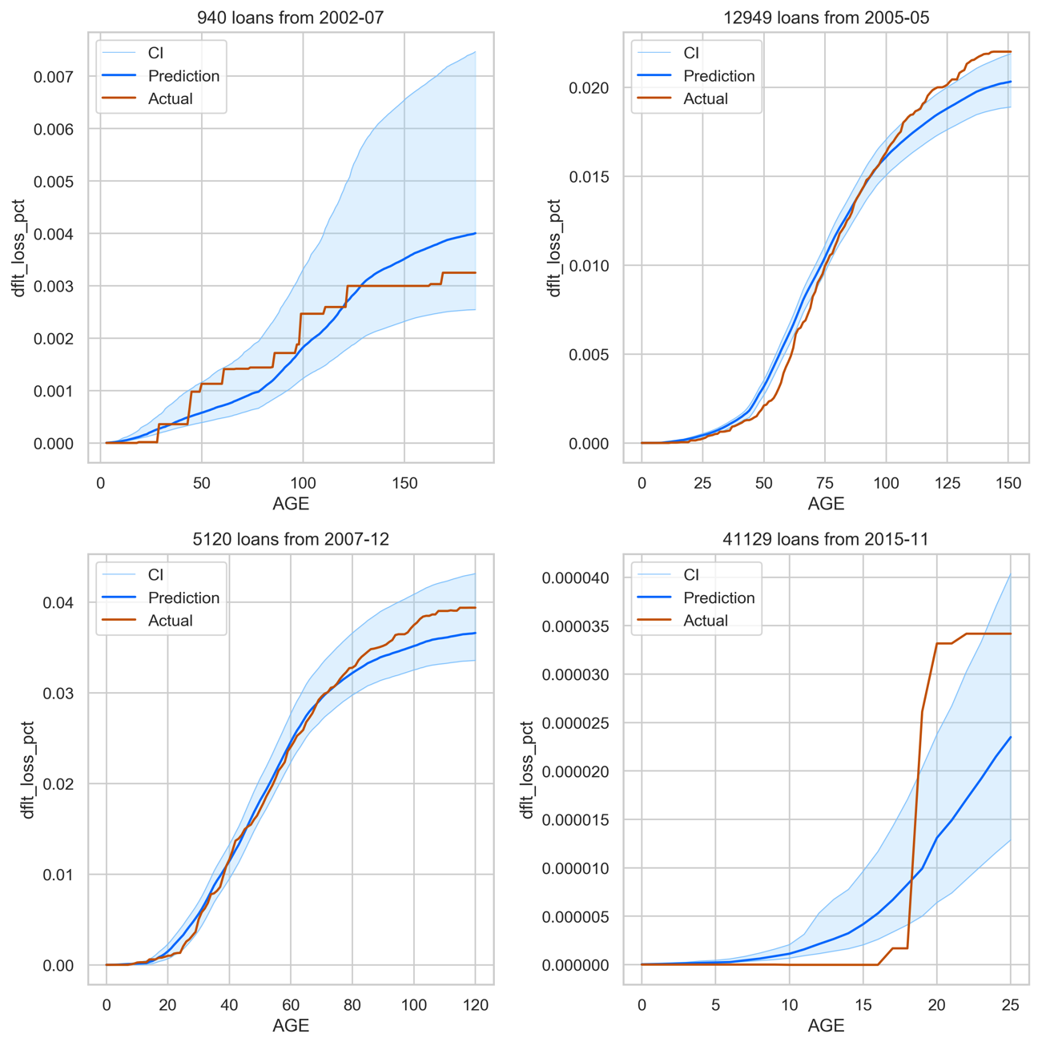

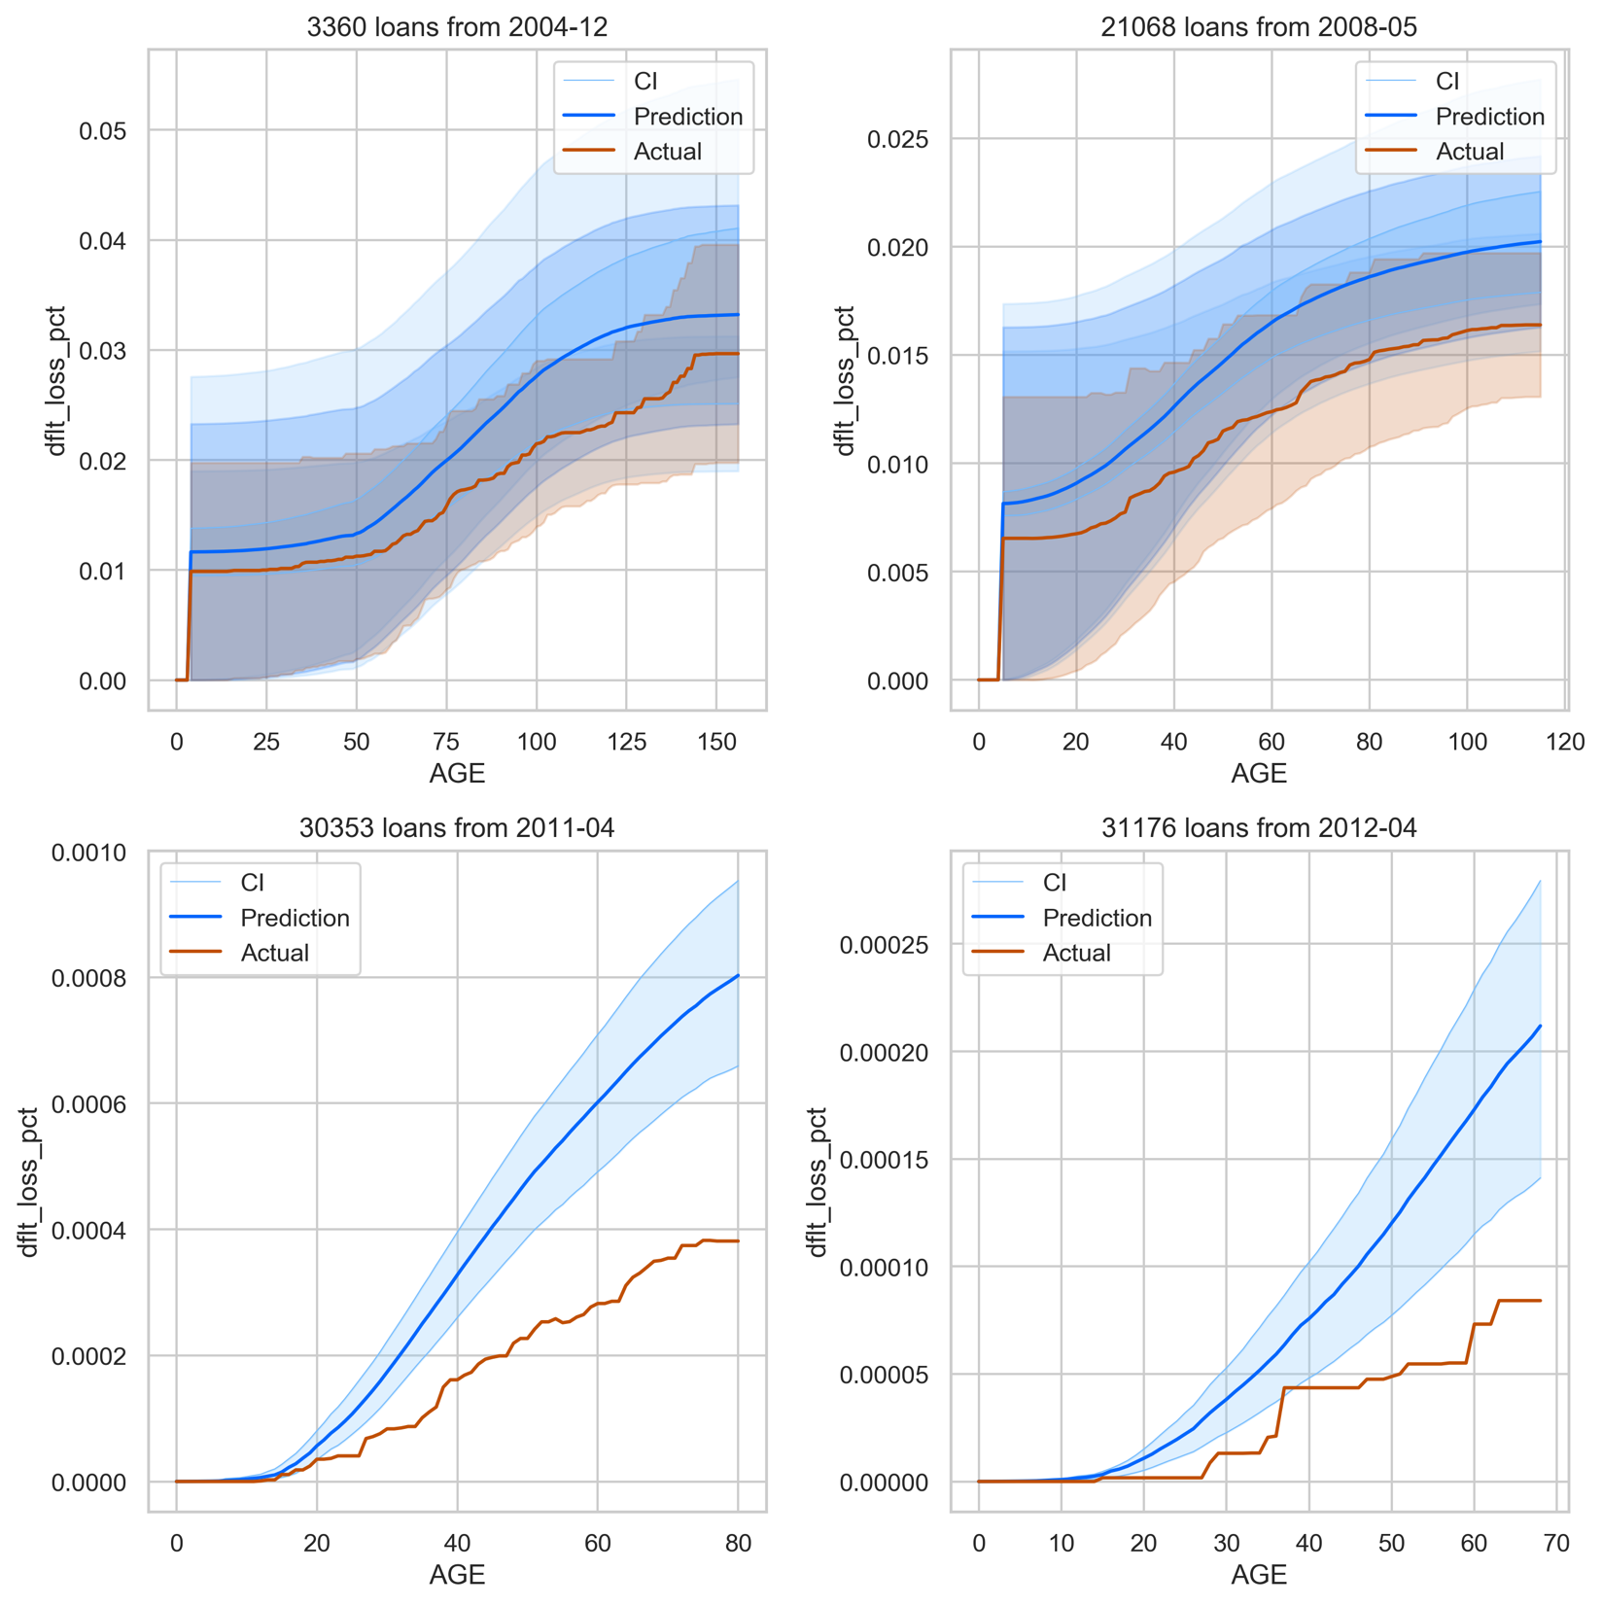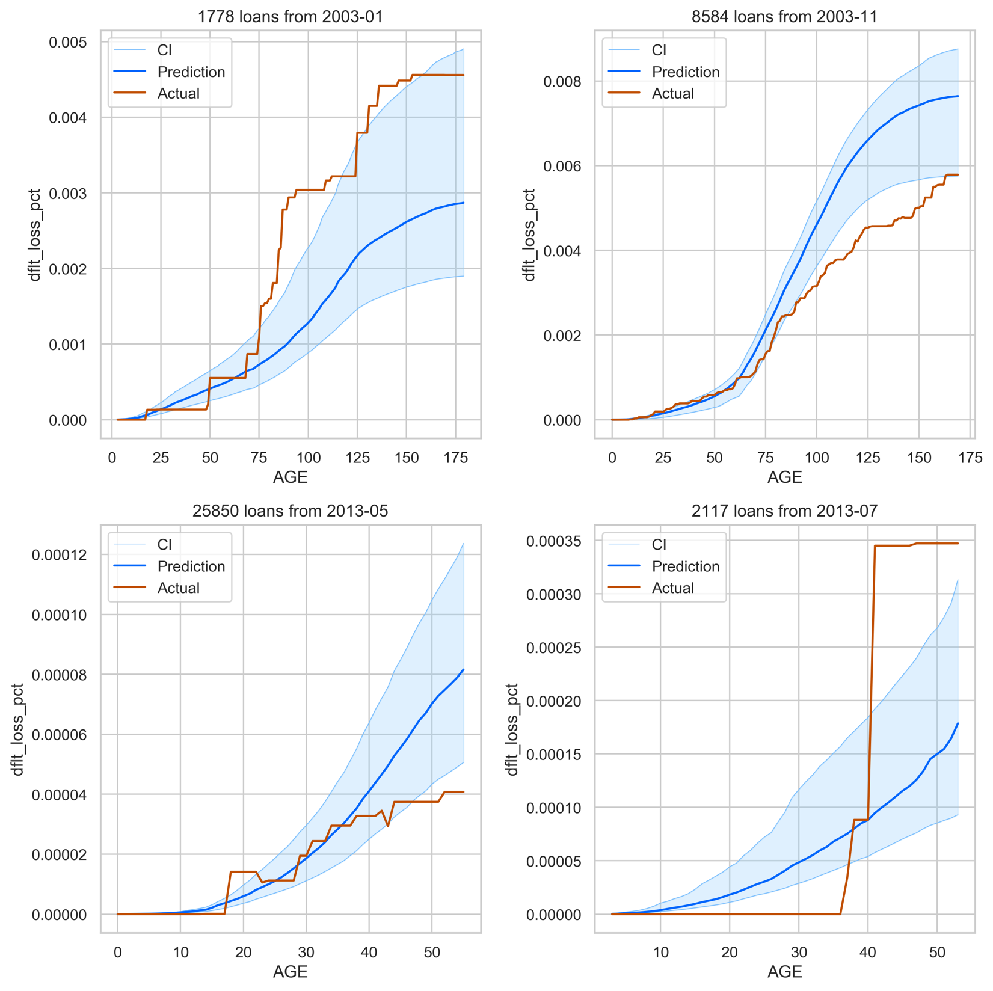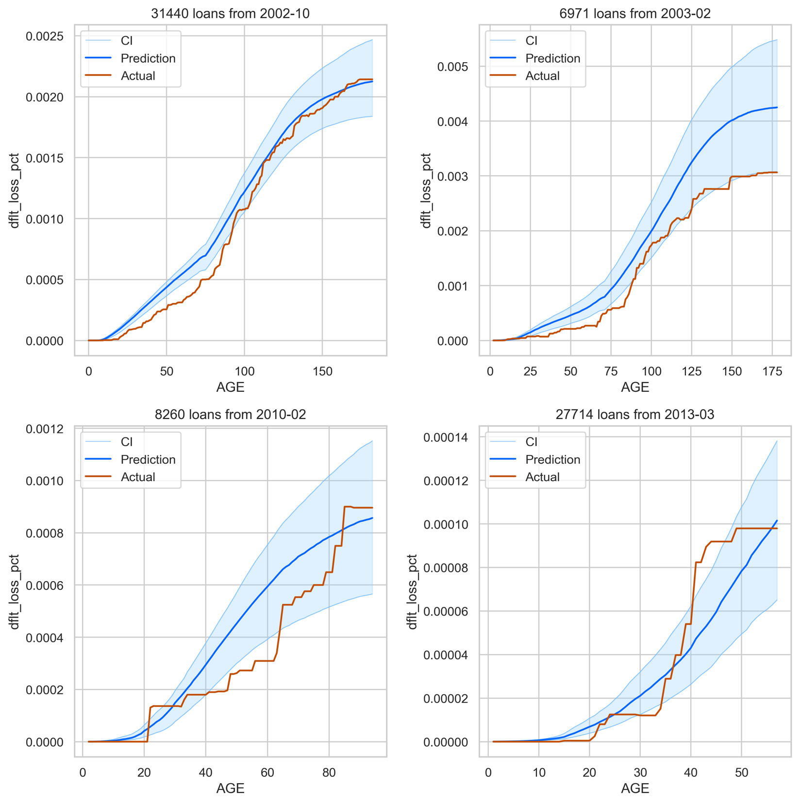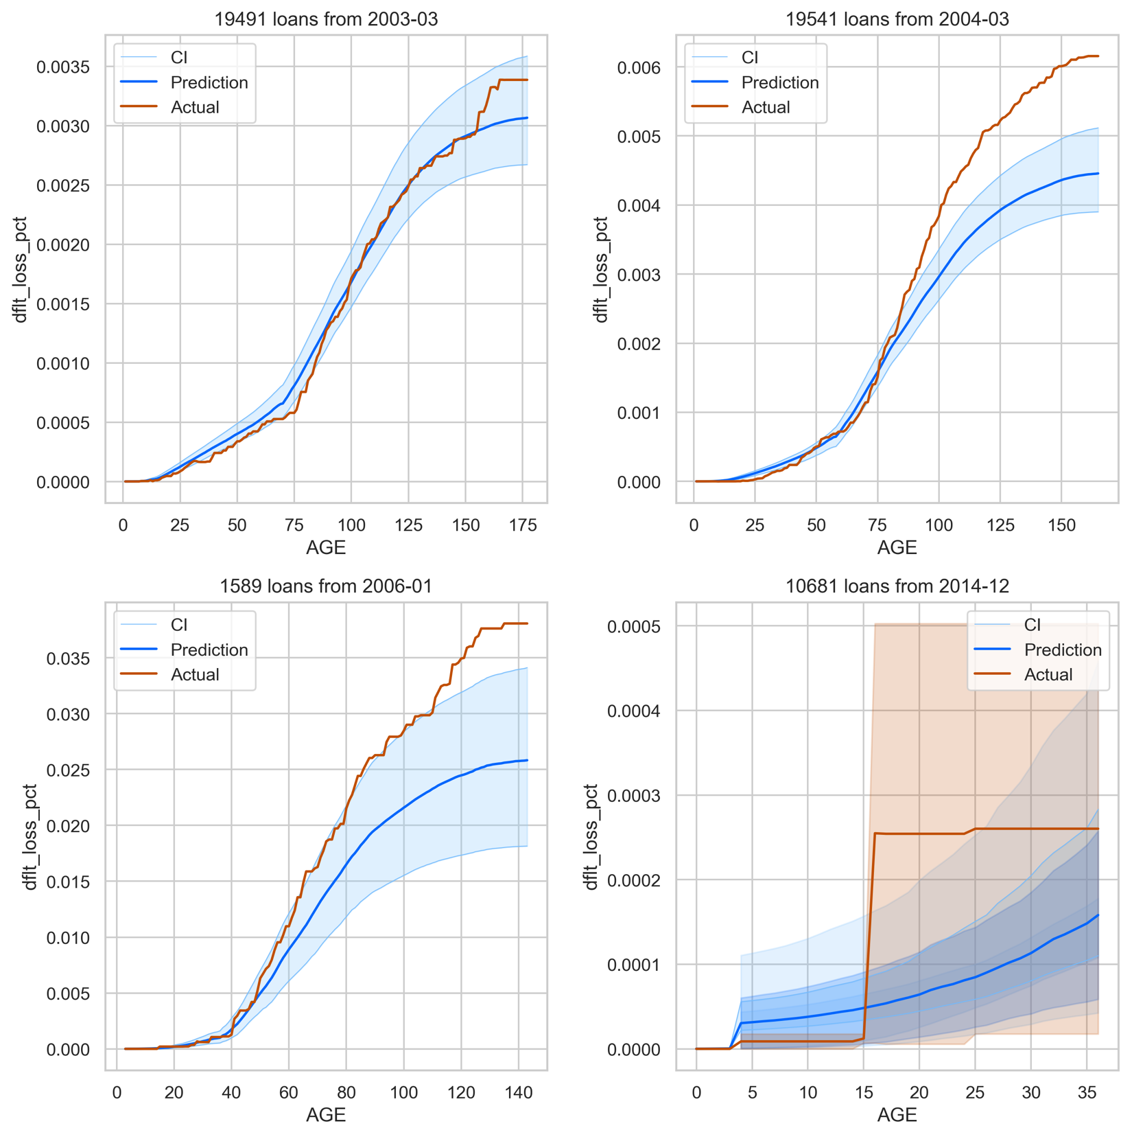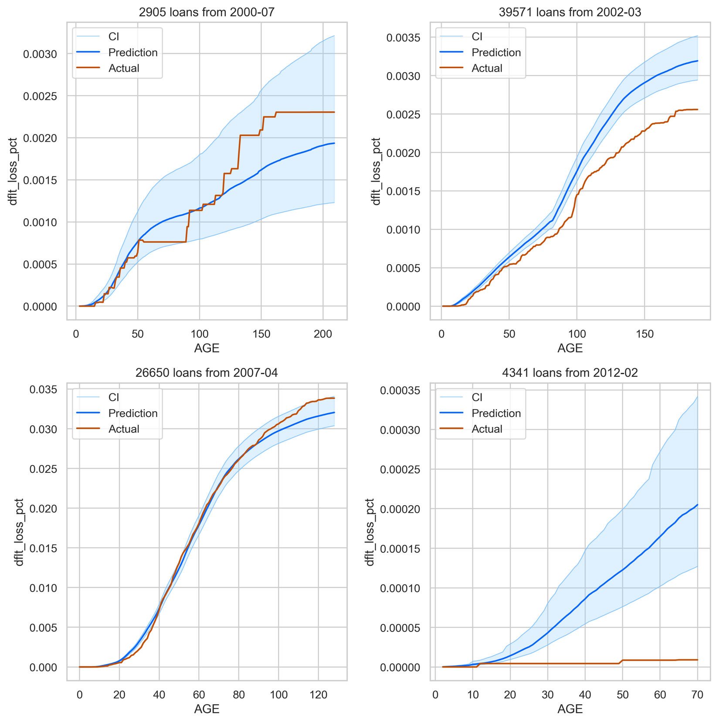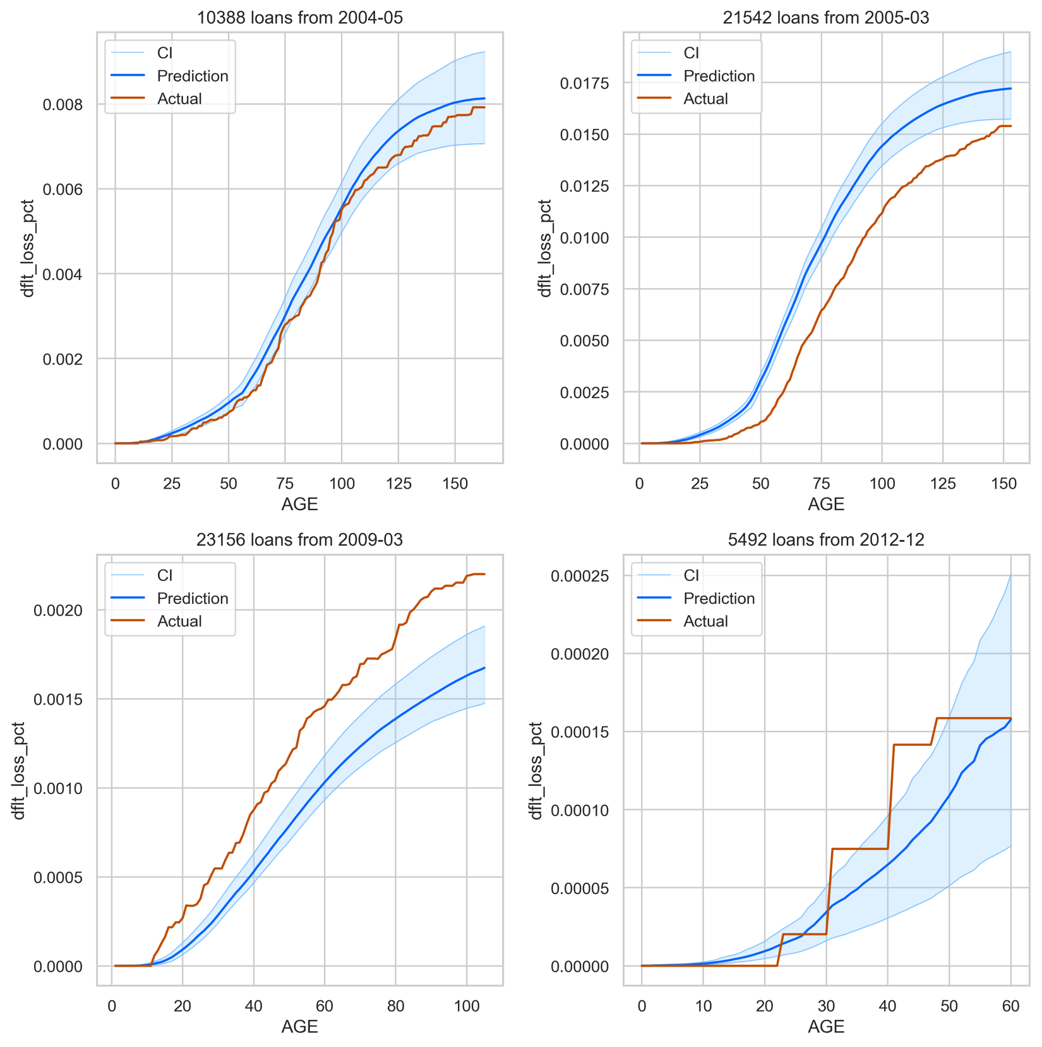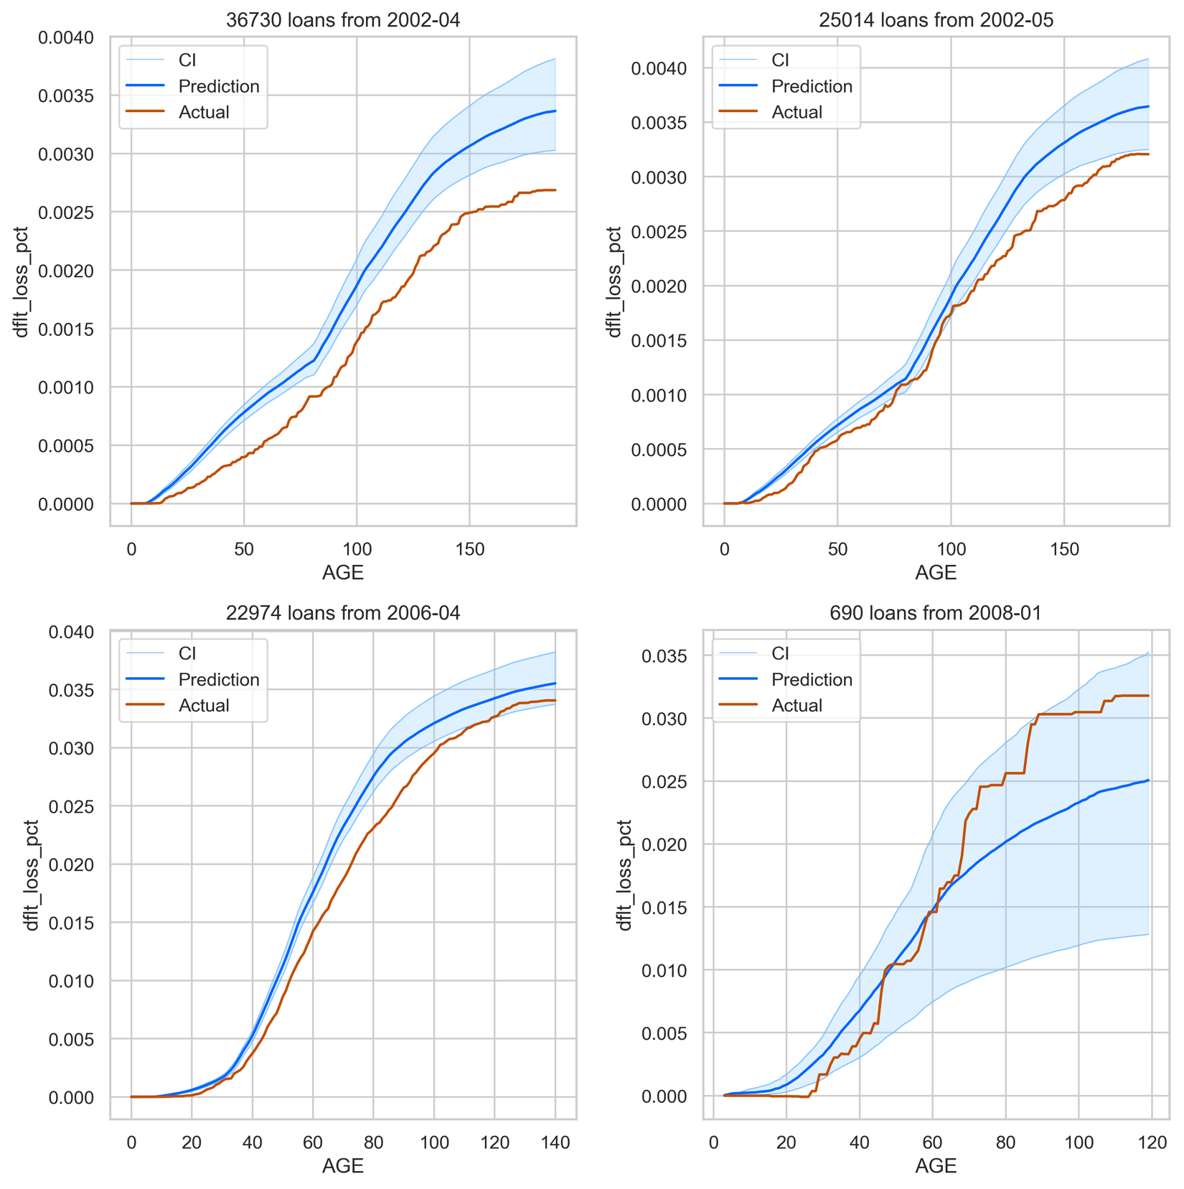

## Model Diagnosis (GBC-OLS-OLS)

Dfdf

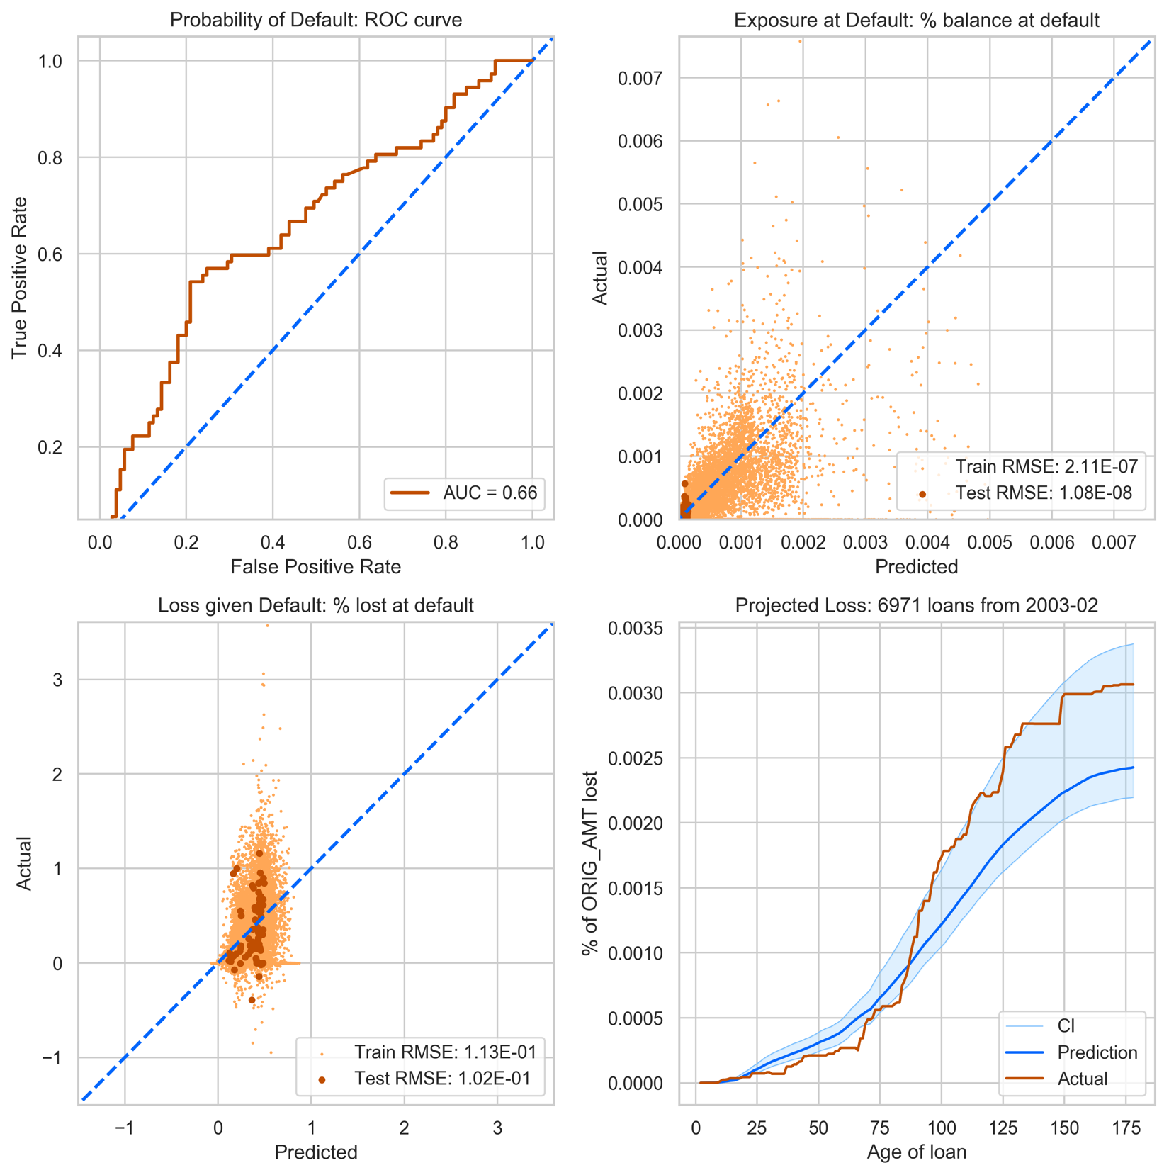

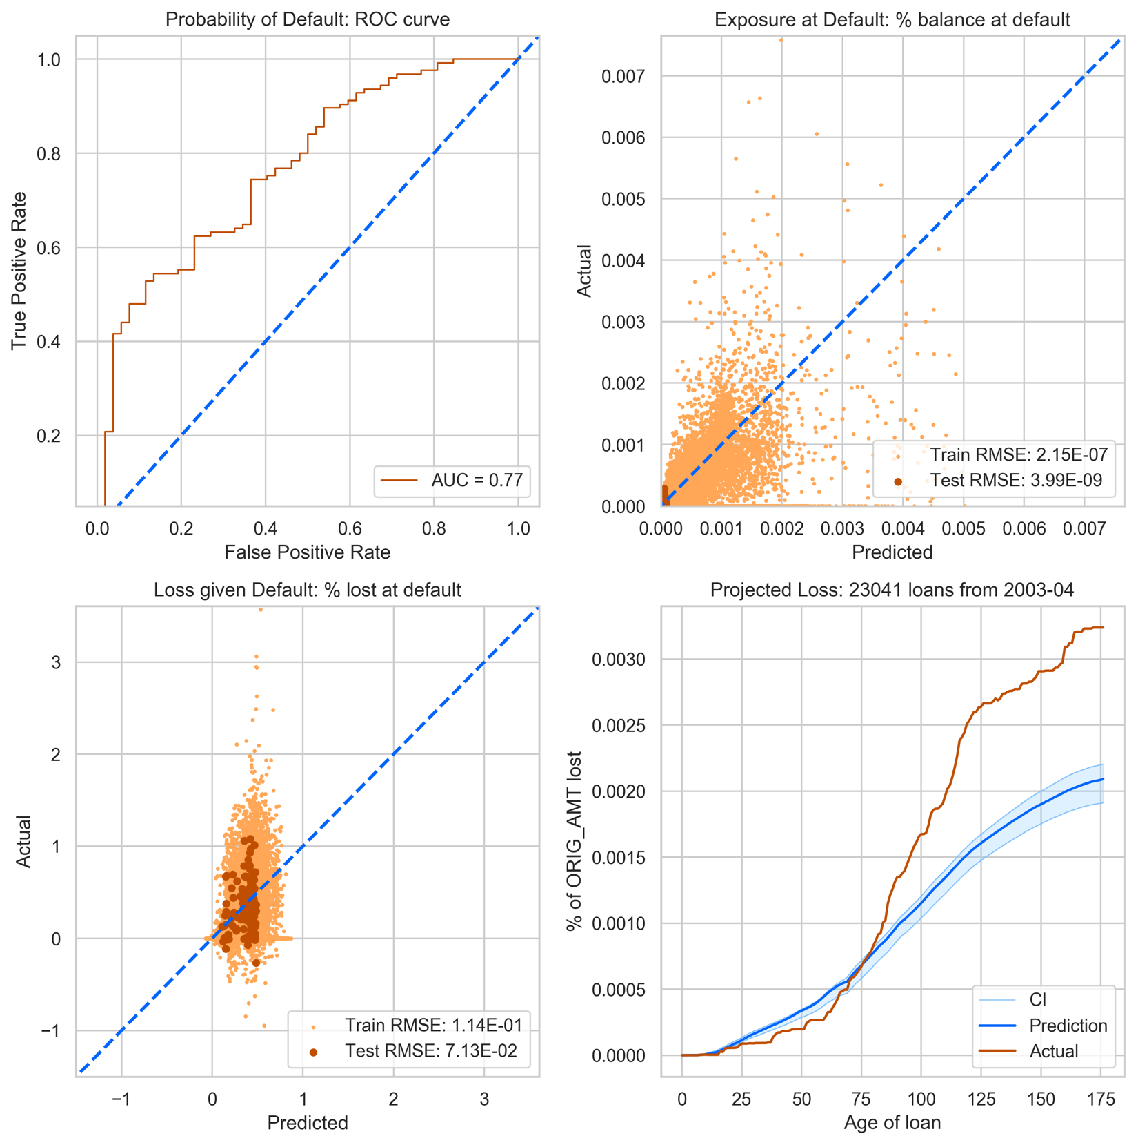

## Model Diagnosis (GBC-RFR-RFR)

dfds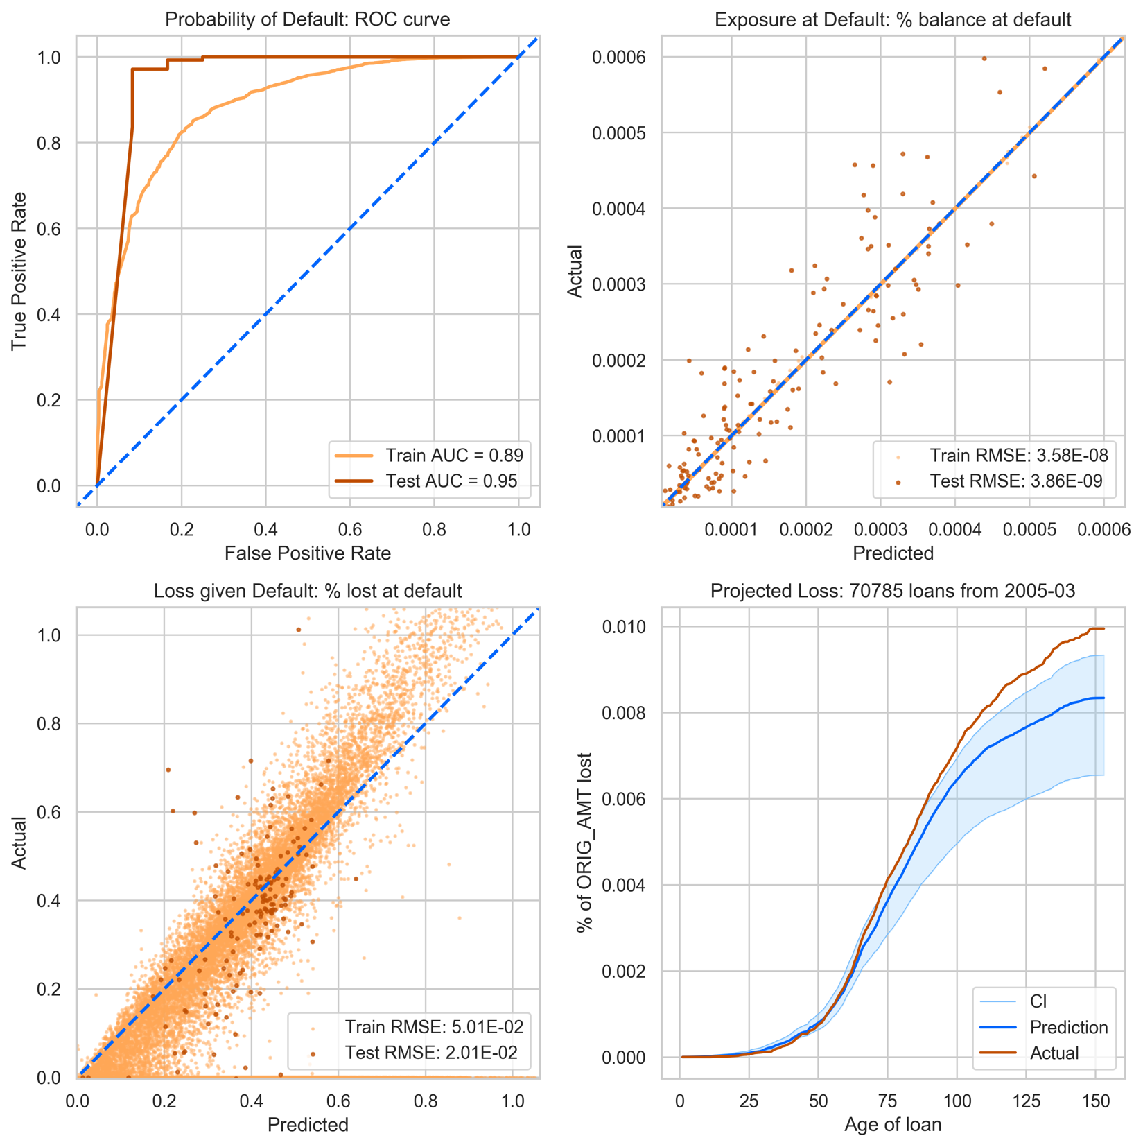

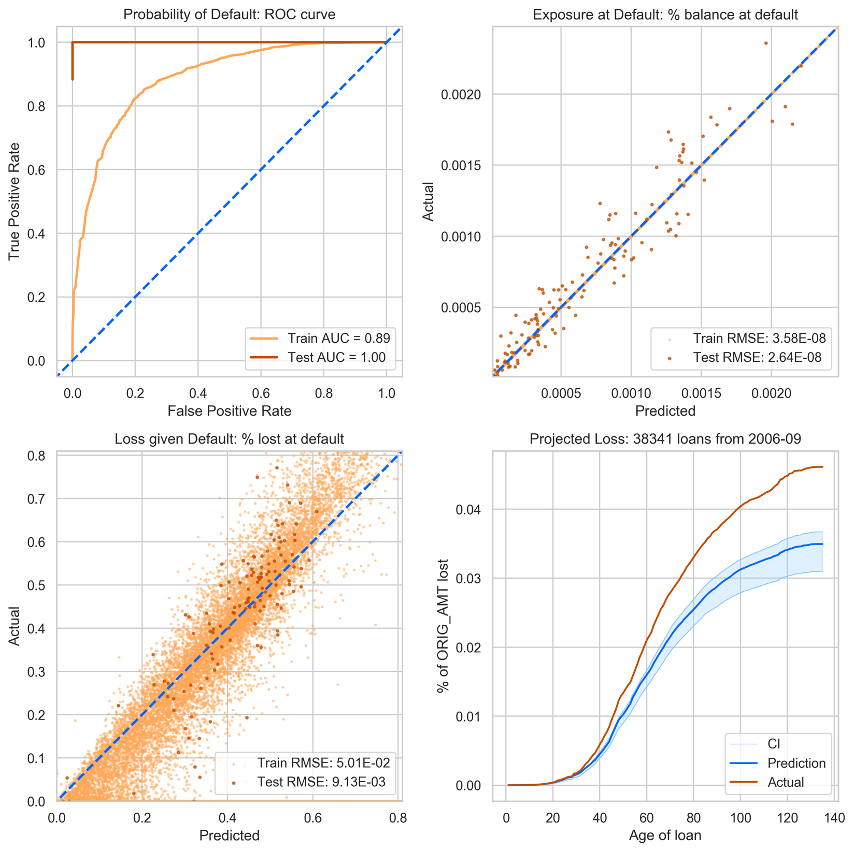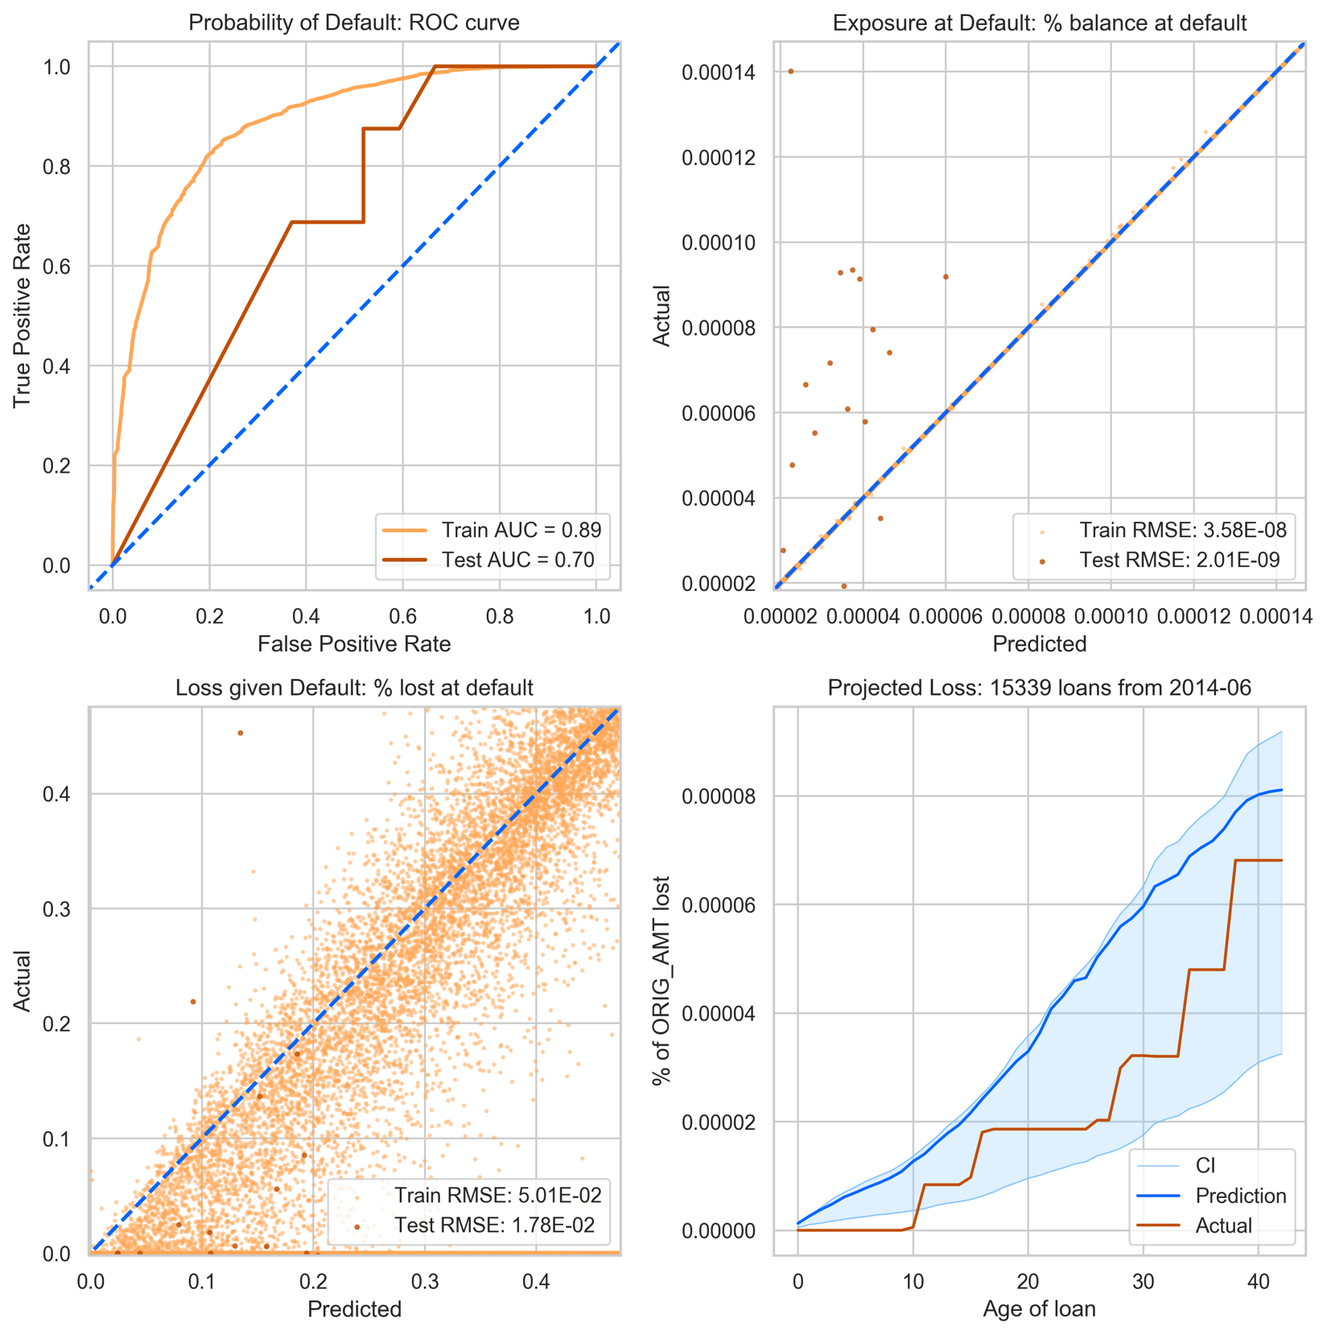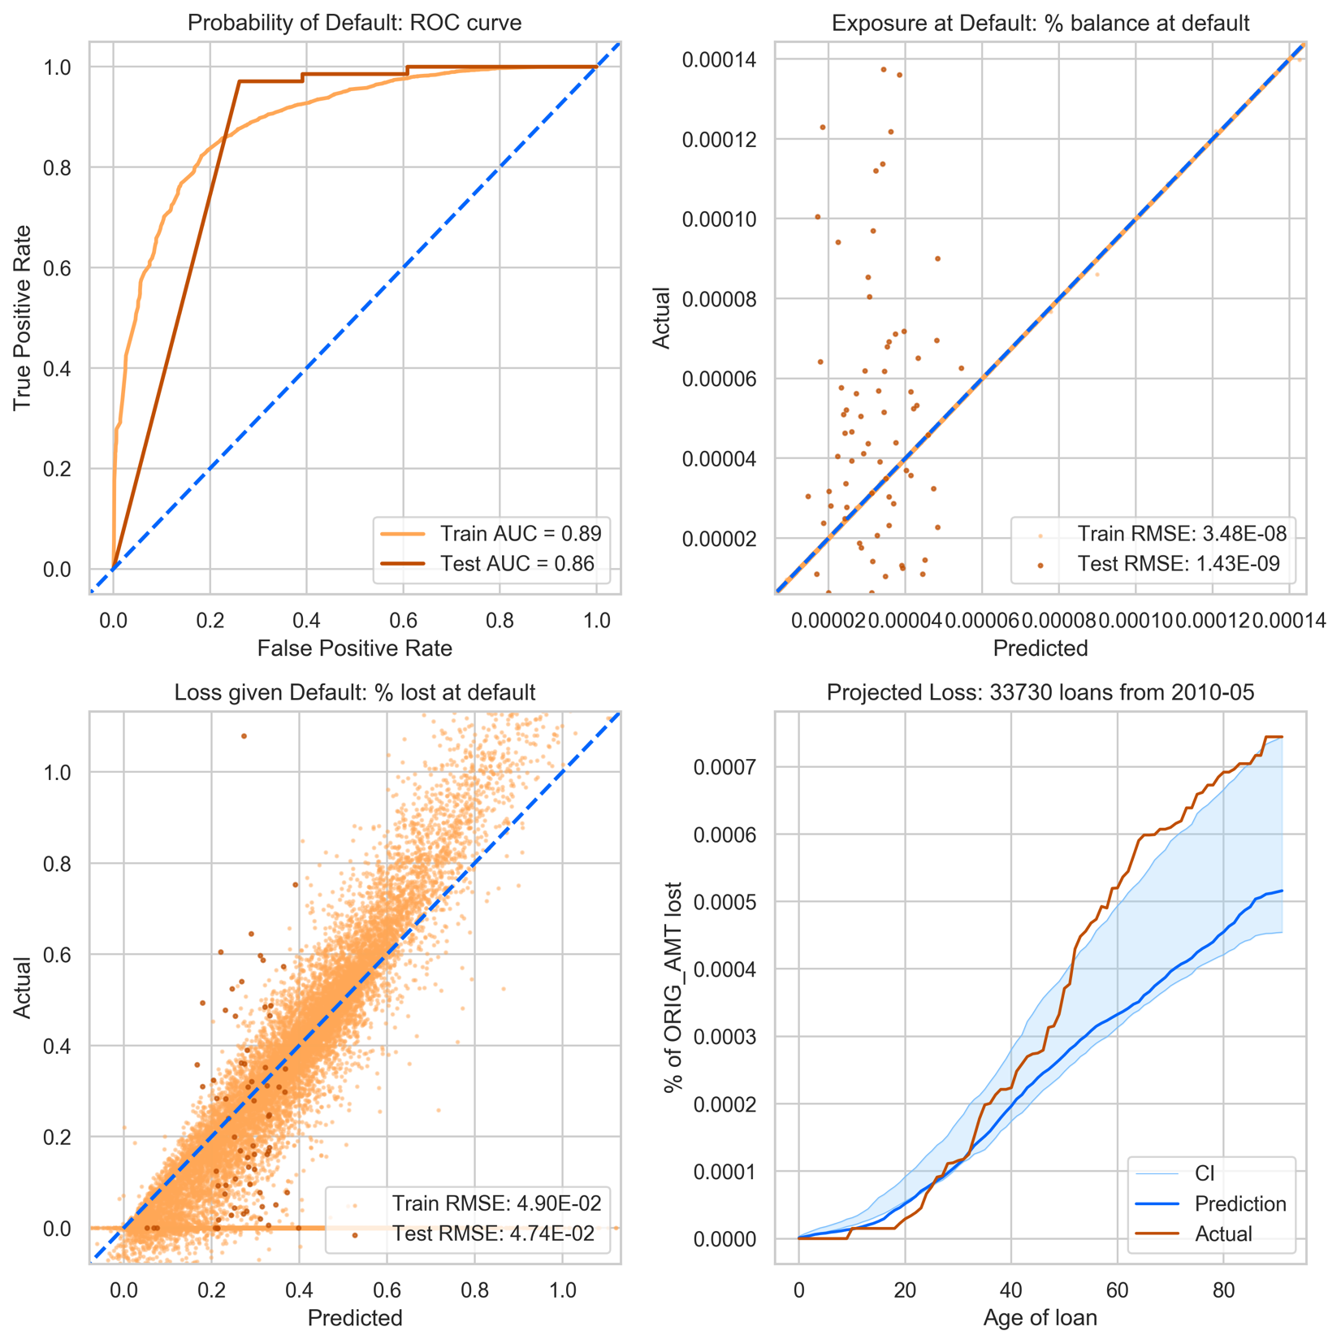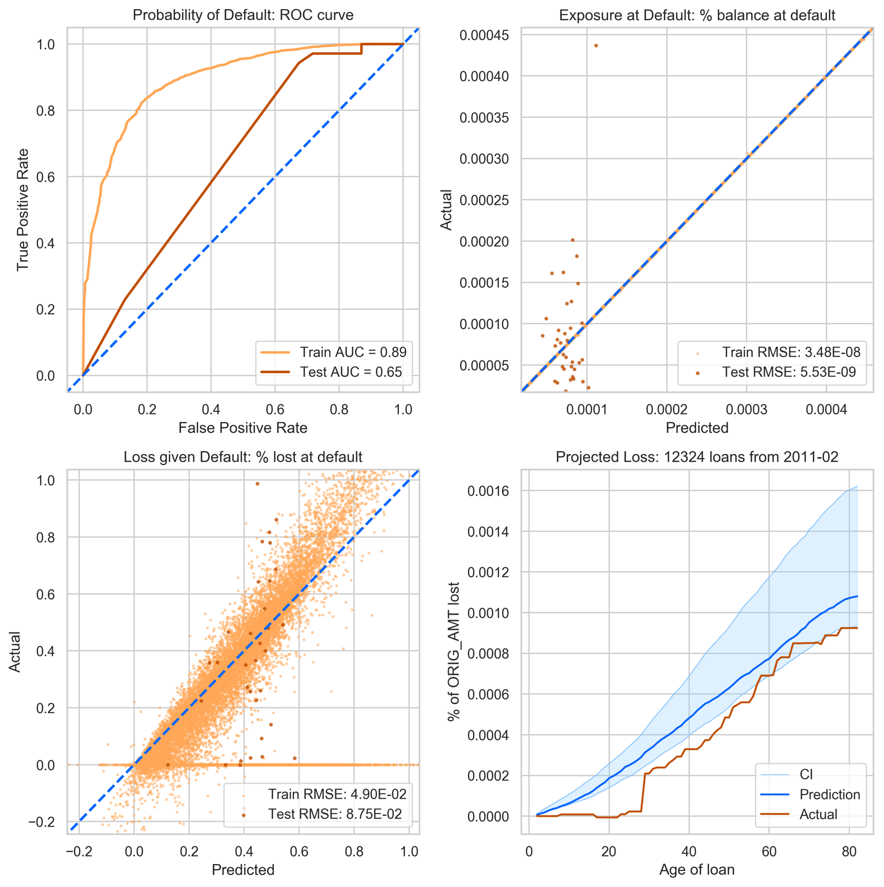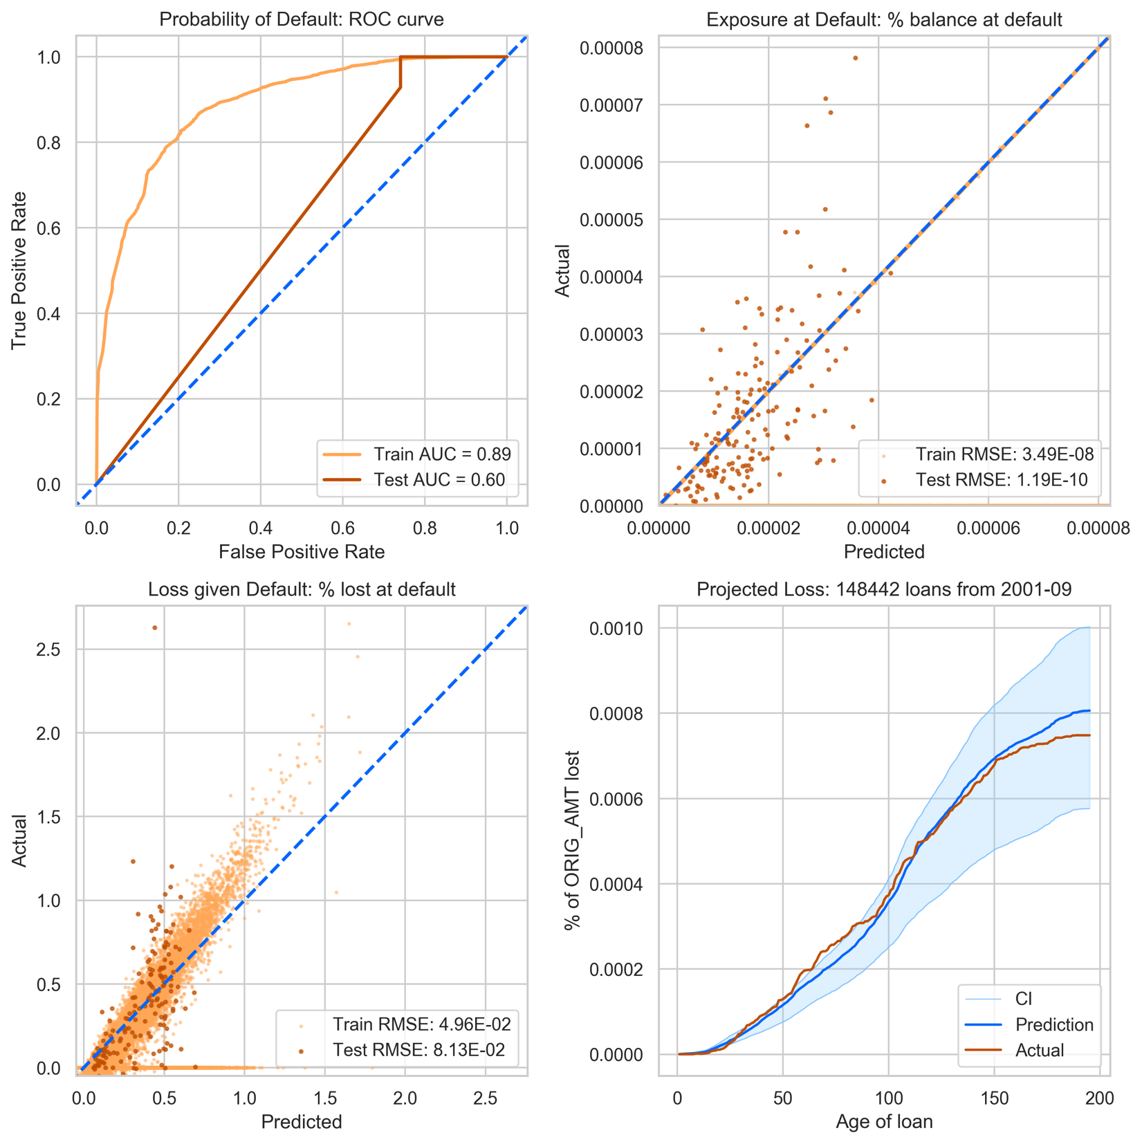

# Next steps

|  |  |  |  |
| --- | --- | --- | --- |
|  | Probability of Default_t  P(loan defaults in month t) | Exposure at Default_t  UPB after dflt in month t | Loss given Default_t  Net loss after disposal in t |
| Vintage | GBM | LM | LM |
| Individual | Cox? |  |  |

References

Leathwick, J. R., Elith, J., Francis, M. P., Hastie, T., & Taylor, P. (2006). Variation in demersal fish species richness in the oceans surrounding new zealand: An analysis using boosted regression trees.*Mar Ecol Prog Ser, 321*, 267-281. Retrieved from <https://www.int-res.com/abstracts/meps/v321/p267-281/>